* 轻量级进行功能注册

轻量级：<http://172.18.44.31:8090/portal/action/frame/welcome>

00045

2345wert

1、功能注册

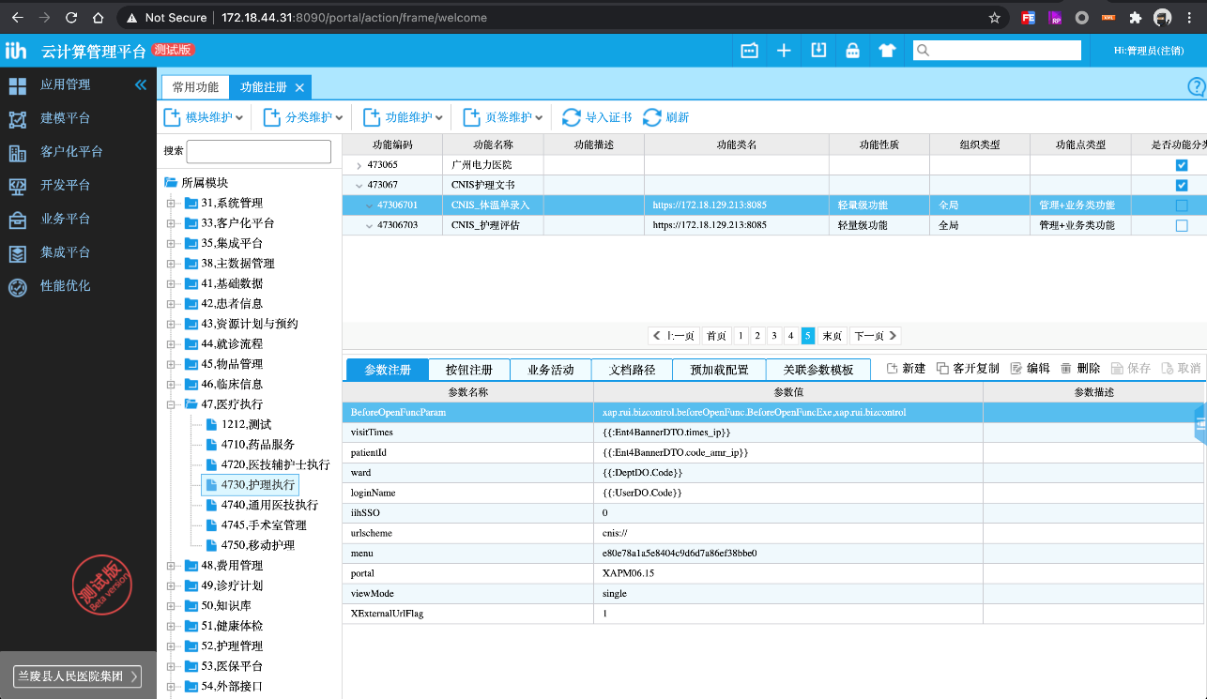

2、菜单注册

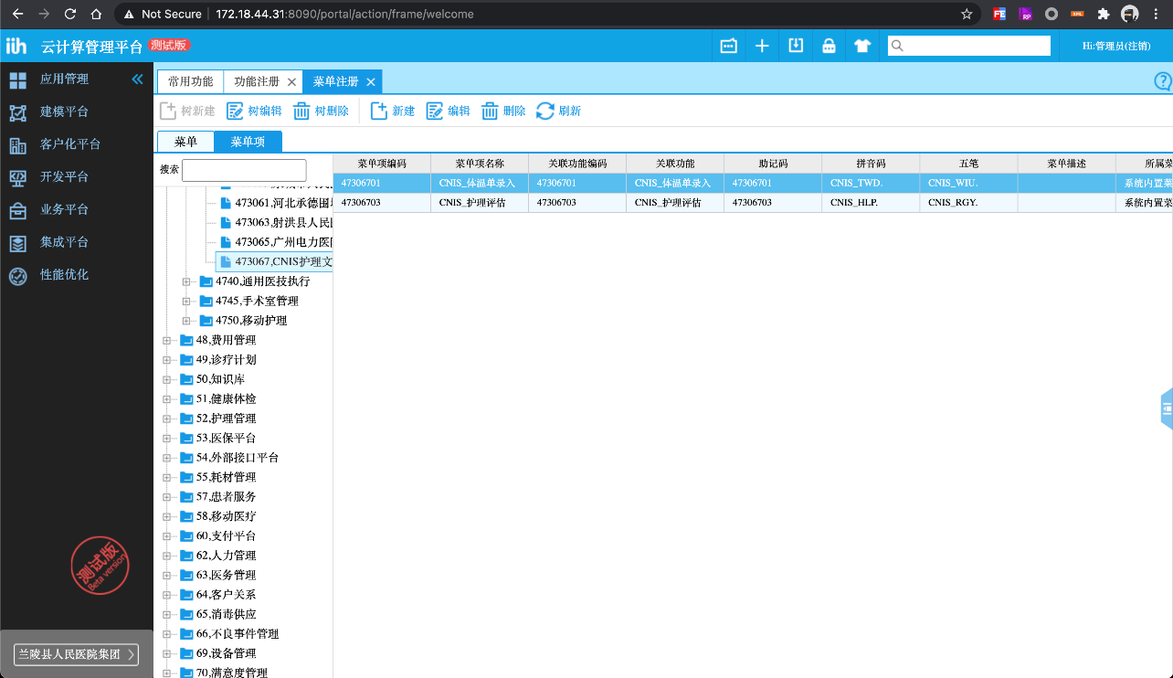

3、给职责分配功能

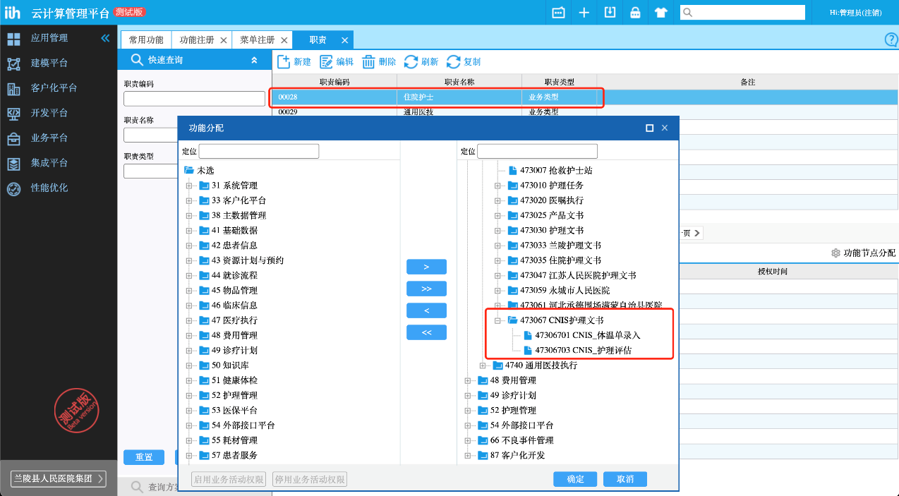

4、业务门户装配

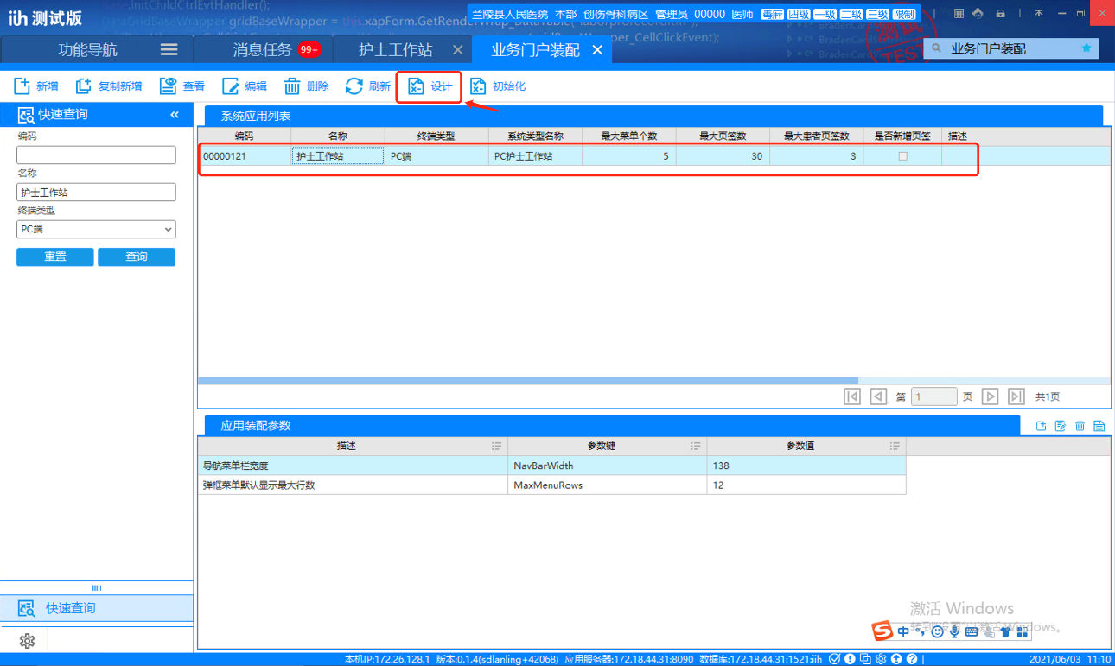

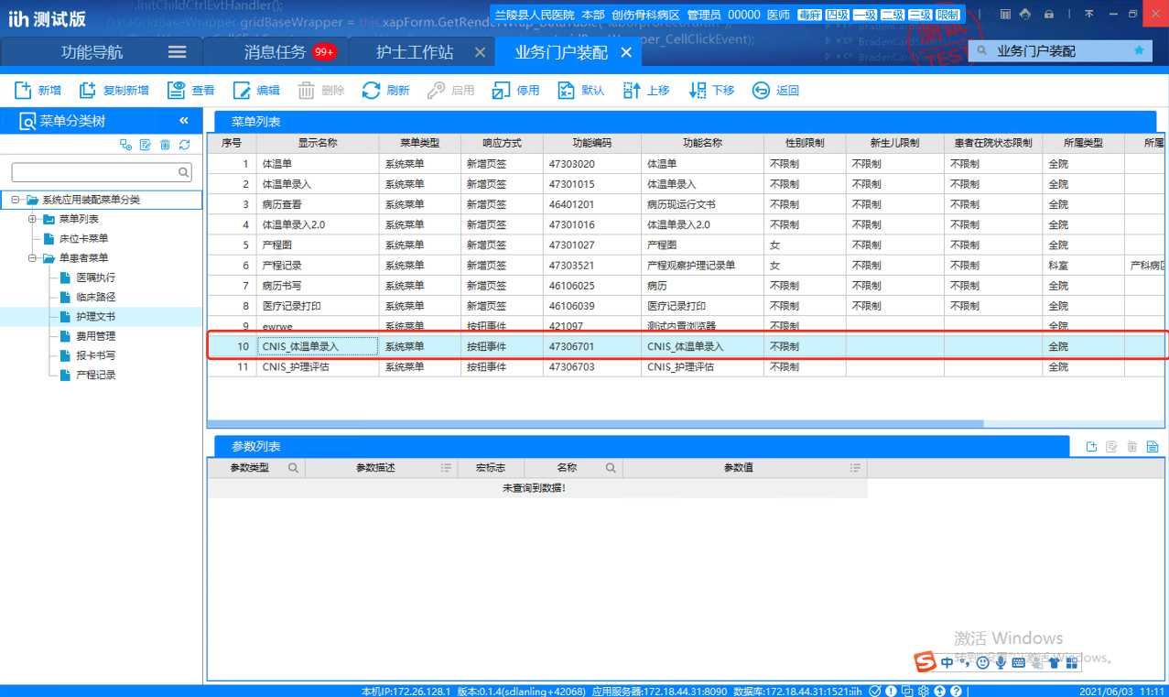

5、效果演示

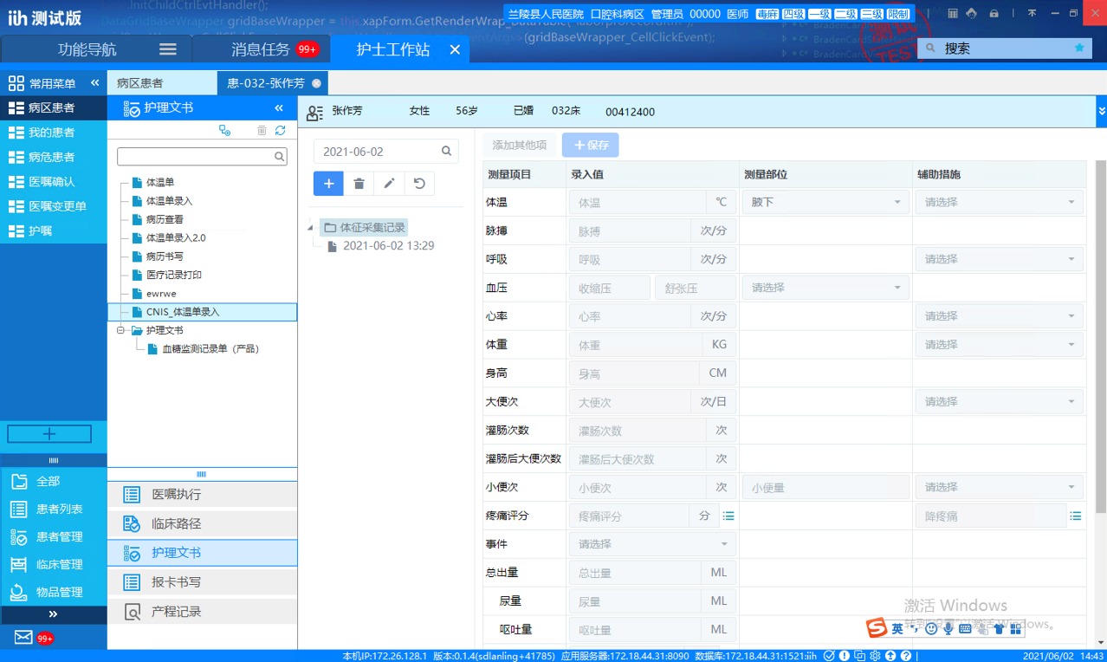

* URL说明

入参说明：

viewMode：查看方式，固定值single

portal：门户 护士站为：XAPM06.15

menu:菜单编码，护理系统菜单编码

ward：病区编码

patientId：患者ID，IIH传入code_amr_ip

visitTimes：住院次

loginName：用户登录名，传入用户工号

-- 体温单录入

https://172.18.129.213:8085/?viewMode=single&portal=XAPM06.15&menu=e80e78a1a5e8404c9d6d7a86ef38bbe0&ward=4004&patientId=00010182&visitTimes=1&loginName=00000

-- 体温单批量录入

https://172.18.129.213:8085/?viewMode=single&portal=XAPM06.15&menu=5ed180e5aef644bb84916d6a23ce13b9&ward=4004&patientId=00010182&visitTimes=1&loginName=00000

-- 体温单查看

https://172.18.129.213:8085/?viewMode=single&portal=XAPM06.15&menu=cc6872b8a931490b87c660c61afa4393&ward=4004&patientId=00010182&visitTimes=1&loginName=00000

-- 护理评估

https://172.18.129.213:8085/?viewMode=single&portal=XAPM06.15&menu=779d09aaa9ca4076a4aad40663652595&ward=4004&patientId=00010182&visitTimes=1&loginName=00000

-- 护理记录

https://172.18.129.213:8085/?viewMode=single&portal=XAPM06.15&menu=67A3A0F5BCE049C6A13E57D8EFEAFD5E&ward=4004&patientId=00010182&visitTimes=1&loginName=00000

-- 护理记录

https://172.18.129.213:8085/?viewMode=single&portal=XAPM06.15&menu=67A3A0F5BCE049C6A13E57D8EFEAFD5E&ward=4004&patientId=00010182&visitTimes=1&loginName=00000

-- 护理宣教

https://172.18.129.213:8085/?viewMode=single&portal=XAPM06.15&menu=96c29487985c4328a910a7ff2a7be303&ward=4004&patientId=00010182&visitTimes=1&loginName=00000

-- 知情同意书

https://172.18.129.213:8085/?viewMode=single&portal=XAPM06.15&menu=7f9ad504f73444c78d652880dad691e7&ward=4004&patientId=00010182&visitTimes=1&loginName=00000