1. **新建数据源**

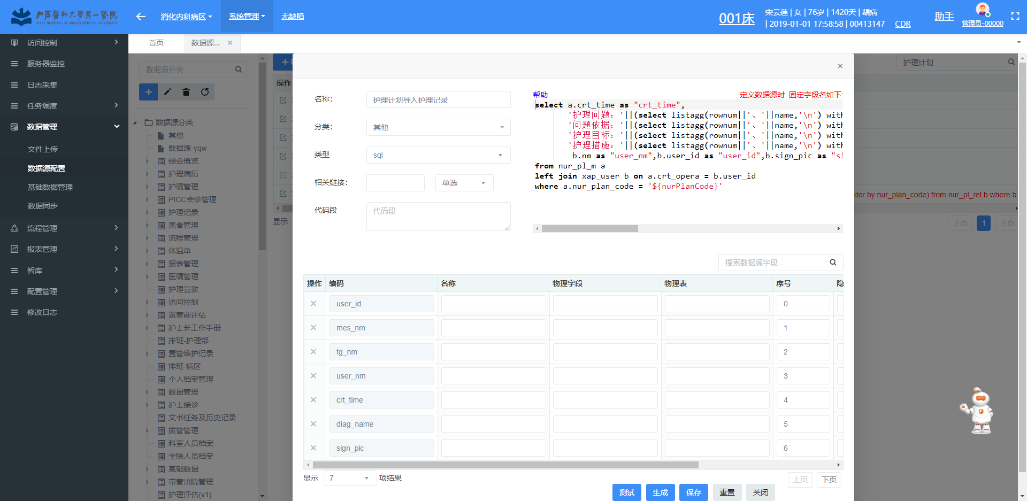

**Oracle:**

select a.crt_time as "crt_time",

'护理问题：'||(select listagg(rownum||'、'||name,'\n') within group(order by ele_type) from nur_ele_app m where m.nur_plan_code = a.nur_plan_code and m.ele_type ='class') ||'\n' as "diag_name",

'问题依据：'||(select listagg(rownum||'、'||name,'\n') within group(order by ele_type) from nur_ele_app m where m.nur_plan_code = a.nur_plan_code and m.ele_type ='yj')||'\n' as "rel_nm",

'护理目标：'||(select listagg(rownum||'、'||name,'\n') within group(order by ele_type) from nur_ele_app m where m.nur_plan_code = a.nur_plan_code and m.ele_type ='target')||'\n' as "tg_nm",

'护理措施：'||(select listagg(rownum||'、'||name,'\n') within group(order by ele_type) from nur_ele_app m where m.nur_plan_code = a.nur_plan_code and m.ele_type ='interv') as "mes_nm",

b.nm as "user_nm",b.user_id as "user_id",b.sign_pic as "sign_pic"

from nur_pl_m a

left join xap_user b on a.crt_opera = b.user_id

where a.nur_plan_code = '${nurPlanCode}'

**SqlServer:**

select a.crt_time as "crt_time",

'护理问题：'+(select convert(varchar(1000),row_number() over (order by m.id_ele_app)) + '、' + m.name + '\n' from nur_ele_app m where m.nur_plan_code = a.nur_plan_code and m.ele_type ='class' for xml path('')) + '\n' as "diag_name",

'问题依据：'+(select convert(varchar(1000),row_number() over (order by m.id_ele_app)) + '、' + m.name + '\n' from nur_ele_app m where m.nur_plan_code = a.nur_plan_code and m.ele_type ='yj' for xml path('')) + '\n' as "rel_nm",

'护理目标：'+(select convert(varchar(1000),row_number() over (order by m.id_ele_app)) + '、' + m.name + '\n' from nur_ele_app m where m.nur_plan_code = a.nur_plan_code and m.ele_type ='target' for xml path('')) + '\n' as "tg_nm",

'护理措施：'+(select convert(varchar(1000),row_number() over (order by m.id_ele_app)) + '、' + m.name + '\n' from nur_ele_app m where m.nur_plan_code = a.nur_plan_code and m.ele_type ='interv' for xml path('')) as "mes_nm",

b.nm as "user_nm",b.user_id as "user_id",b.sign_pic as "sign_pic"

from nur_pl_m a

left join xap_user b on a.crt_opera = b.user_id and b.del_f = '0'

where a.nur_plan_code = '${nurPlanCode}'

1. **配置业务引用模板**

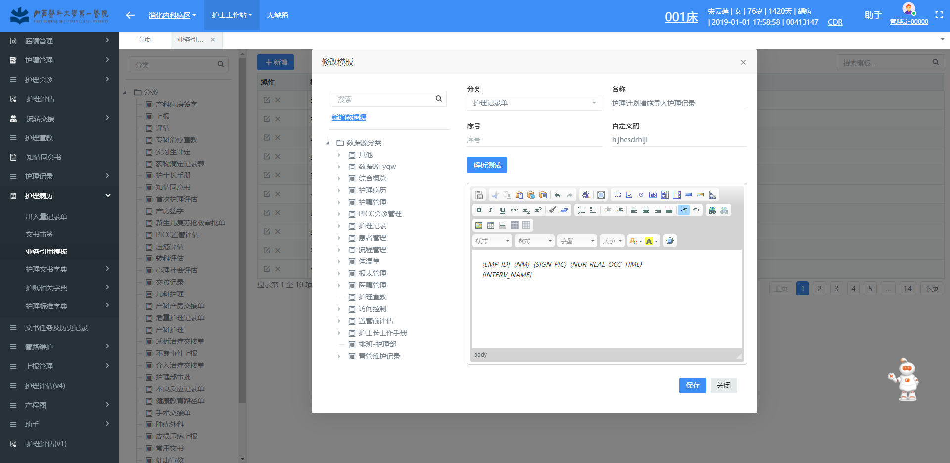

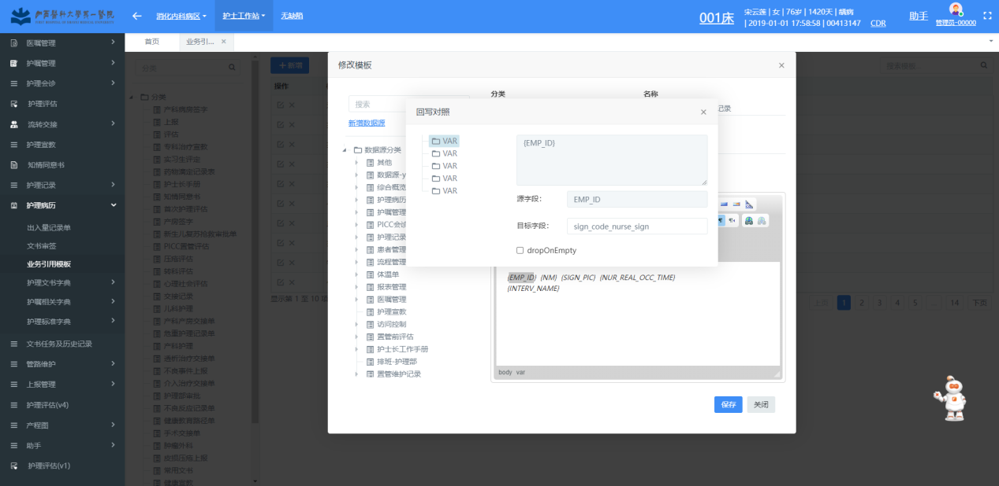

**注意 源字段为数据源select返回字段，目标字段为护理记录单中的列字段编码**

1. **配置流程**

**新增流程**

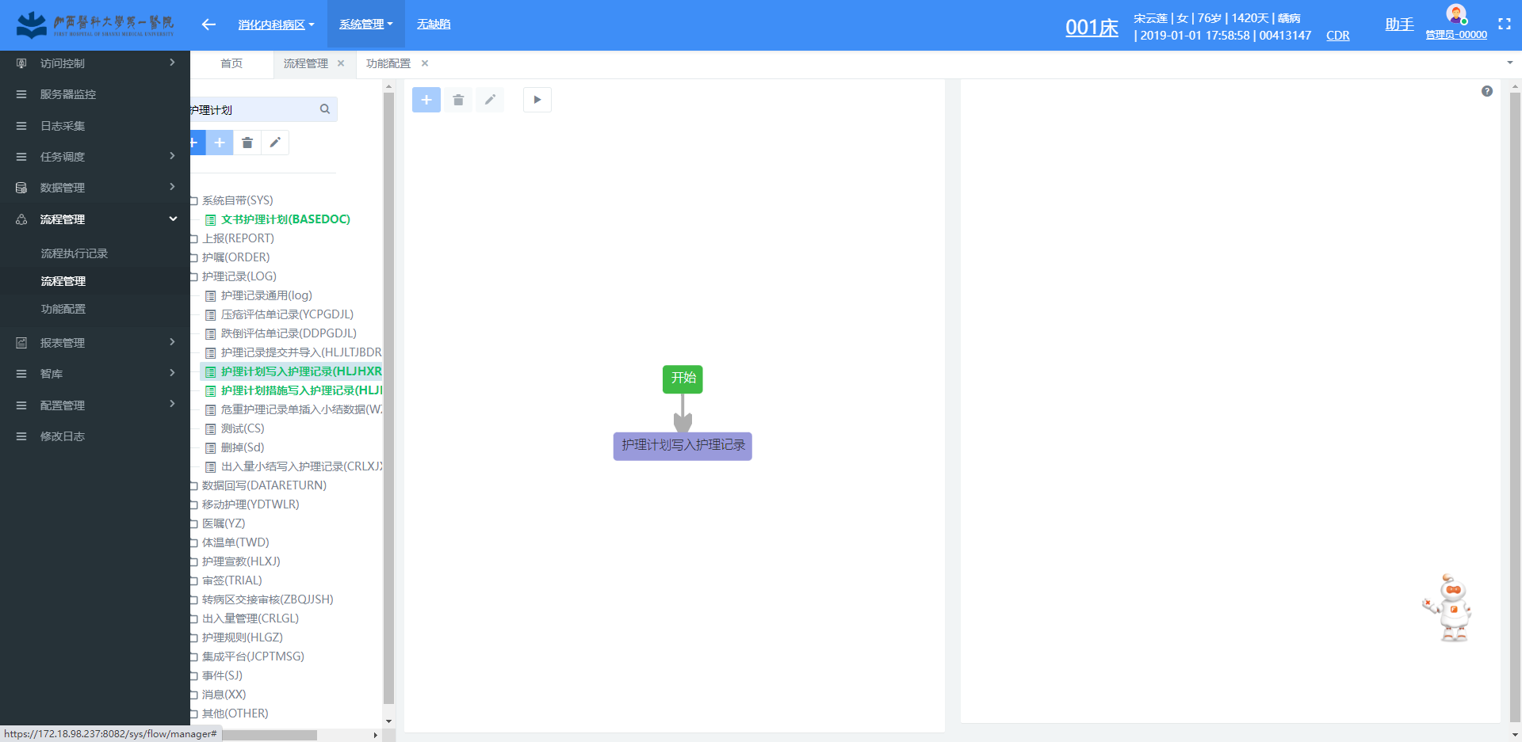

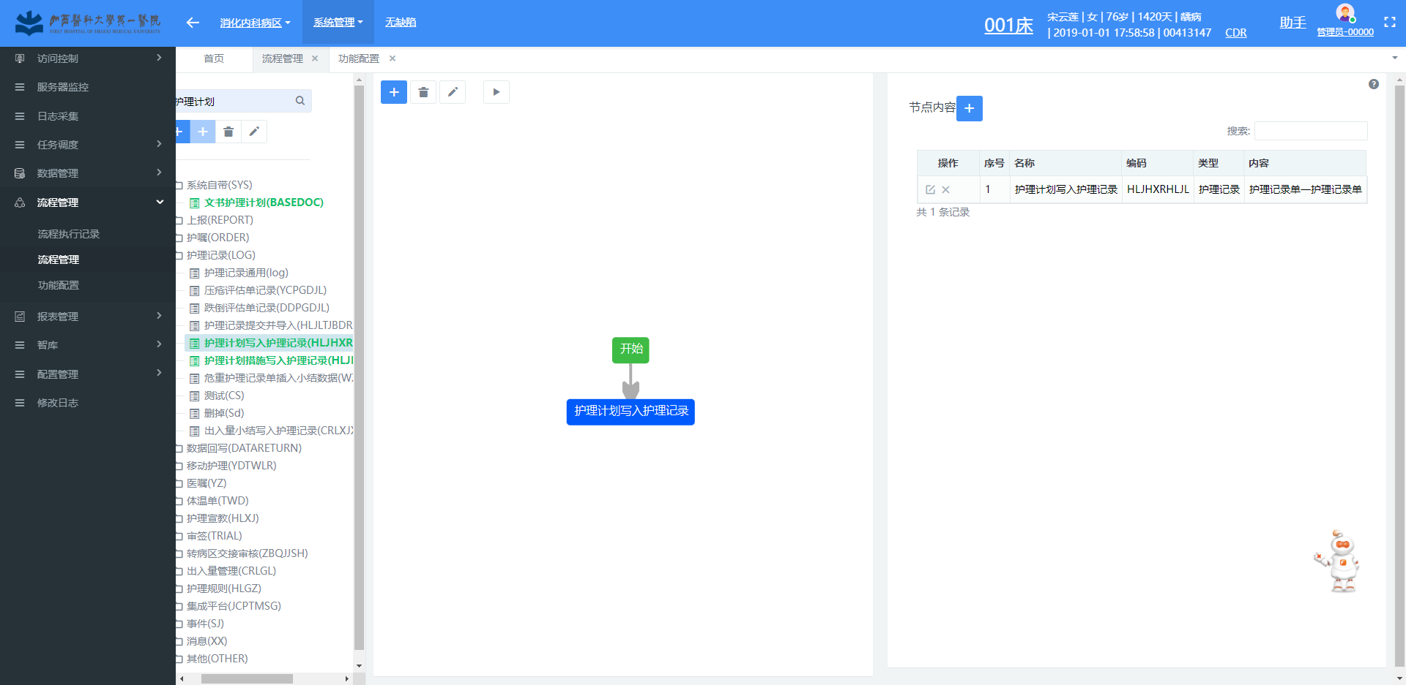

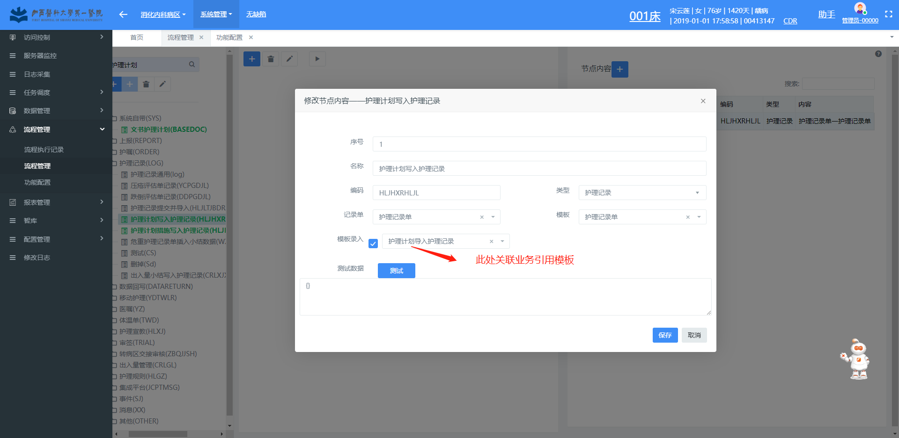

**新增功能**

