首页高危指标趋势展示配置手册

1. 需求

护理站首页通过定义护士动态关注卡在患者床卡能清晰地展示当前患者具有哪些高危风险项，针对患者住院期间的高危风险的变化情况，需要有一个图形化的趋势图展示，需要在点击高危项的时候能够进到详情查看页面，能够查看评估明细及分值变化趋势。

1. 配置步骤
   1. 护士关注卡配置

在综合概览目录下进入护理指标定义页面，新增指标，选择指标类型为护士关注卡，并勾选“护士关注卡标题栏显示”为显示，配置在床卡显示的名称(如高度压疮显示为“疮”)，需要指定一个指标数据来源对应的数据源，只有数据返回数据后，才会在床卡上进行显示。

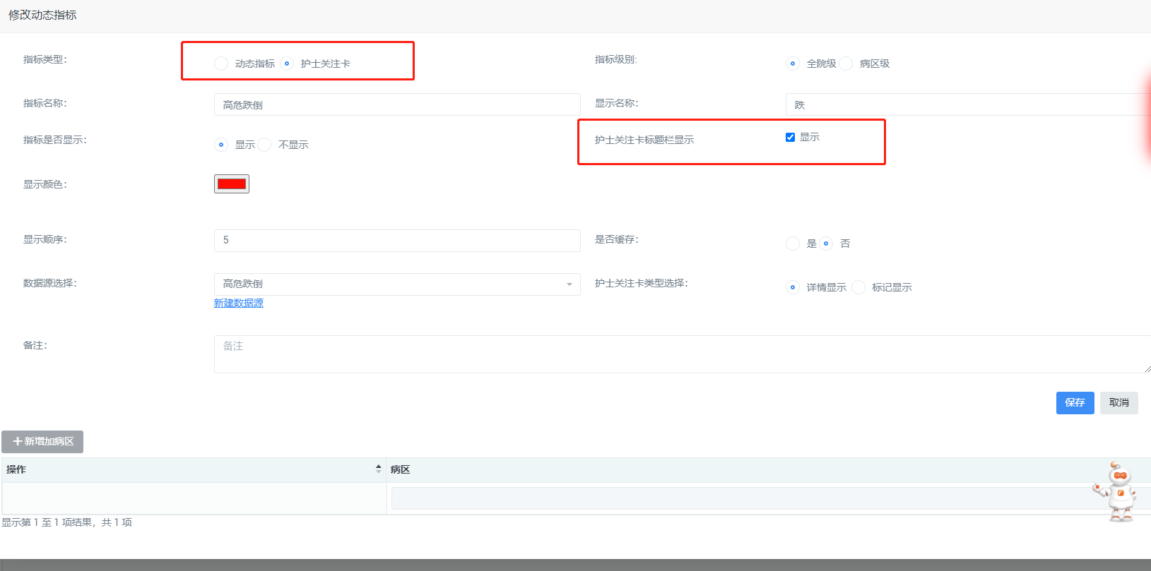

指标可以定义为全院级或病区级，全院无需指定病区均会使用，病区级需要指定显示病区。

* 1. 数据源配置

护士关注卡需要关联数据源获取数据后才能显示，数据源配置需要配置一个高危指标的数据，只提取患者最新的文书评估分值进行判断处理，但在查询明细时需要展示对应文书的所有评估明细，所以，约定高危指标明细数据的名称由【dtl_高危指标名称】构成，如，高危指标名称为：高度压疮，则对应明细项的名称为：dtl_高度压疮，所有关注卡类的指标同理创建即可使用。 以高度压疮关注卡为例：在系统管理->数据管理->数据源配置新增指标(如果系统已经预置，则直接修改即可)，维护名称为：高度压疮，编写数据查询脚本，生成返回列，保存数据源：

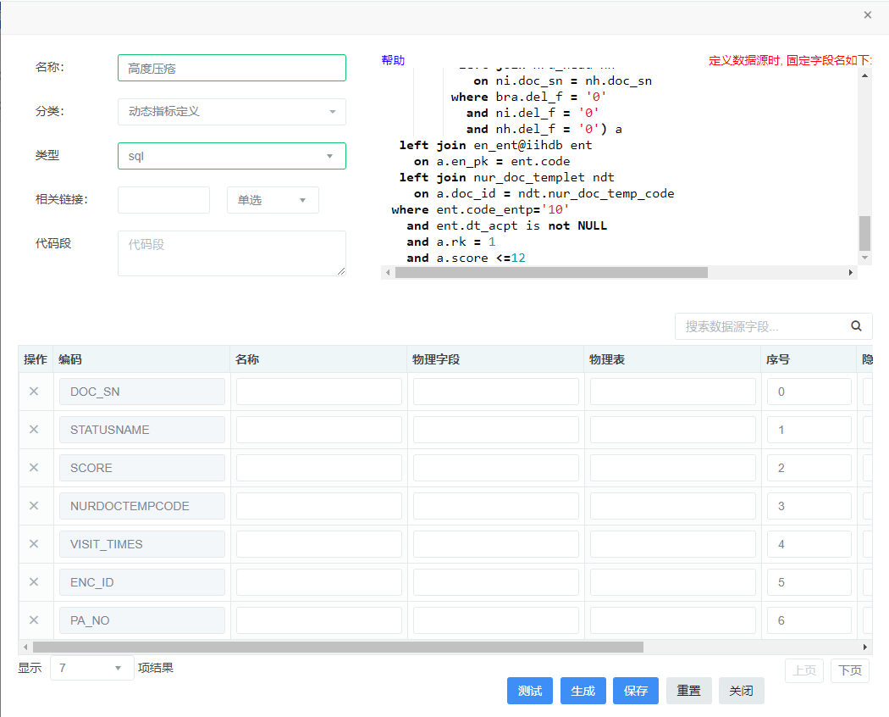

按照系统约定，护理系统约定在调用数据源时会传入预置参数：

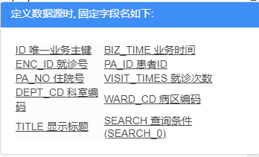

会将外部传入参数和上述SQL脚本的返回列进行对比，完全一致时，则会使用外部参数值生成一个过滤条件，程序处理时会将脚本包装成：select temp.* from (_sql_) as temp where 1=1的格式，所以能作为条件的列必须内部SQL能查询出来的列，在高危指标处理时，只取最新一条记录，一般sql会如下面脚本所示：

select a.rsn as ID,

a.record_date as BIZ_TIME,

a.en_pk as ENC_ID,

a.pid as PA_ID,

a.ad_no as PA_NO,

a.visit_times as VISIT_TIMES,

a.dept as DEPT_CD,

a.ward as WARD_CD,

'压疮' as TITLE,

ndt.version_num as VERSION,

ndt.nur_doc_temp_code as NURDOCTEMPCODE,

ndt.nur_doc_temp_name as TASKNM,

a.doc_sn as DOC_SN,

a.rsn as RSN,

a.record_date as SUBTIME,

a.score as SCORE,

a.statusname as STATUSNAME,

a.nm as NM

from (select bra.rsn as rsn,

bra.record_time as record_date,

nh.en_pk as en_pk,

nh.pid as pid,

nh.ad_no as ad_no,

nh.visit_times as visit_times,

nh.dept as dept,

nh.ward as ward,

nh.doc_id as doc_id,

nh.doc_sn as doc_sn,

bra.score as score,

CASE WHEN bra.score >= 19 THEN '无风险'

when bra.score >= 15 then

'低度危险'

when bra.score >= 13 and bra.score <= 14 then

'中度危险'

when bra.score >= 10 and bra.score <= 12 then

'高度危险'

when bra.score <= 9 then

'极度危险'

else

''

end AS statusname,

bra.sign_name_hushiqianming AS nm,

--对同一患者的数据按时间倒序编号

row_number() over(partition by ni.en_pk order by bra.record_time desc) as rk

FROM nrd_data_ycfxpgbzz bra

left join nrd_item ni

on bra.rsn = ni.rsn

left join nrd_head nh

on ni.doc_sn = nh.doc_sn

where bra.del_f = '0'

and ni.del_f = '0'

and nh.del_f = '0') a

left join en_ent@iihdb ent

on a.en_pk = ent.code

left join nur_doc_templet ndt

on a.doc_id = ndt.nur_doc_temp_code

where ent.code_entp='10'

and ent.dt_acpt is not NULL

and a.rk = 1 --只取第一条记录

and a.score <=12 –第一条记录小于等于12分时为高度压疮

查询时按病区查询时即有一次性将本病区和关注卡相关联的数据查询返回再进行进行处理。

定义明细数据源时，可直接使用高危指标的脚本，去掉and a.rk = 1和分值限定and a.score <=12，直接取出所有和高危指标关联的数据：

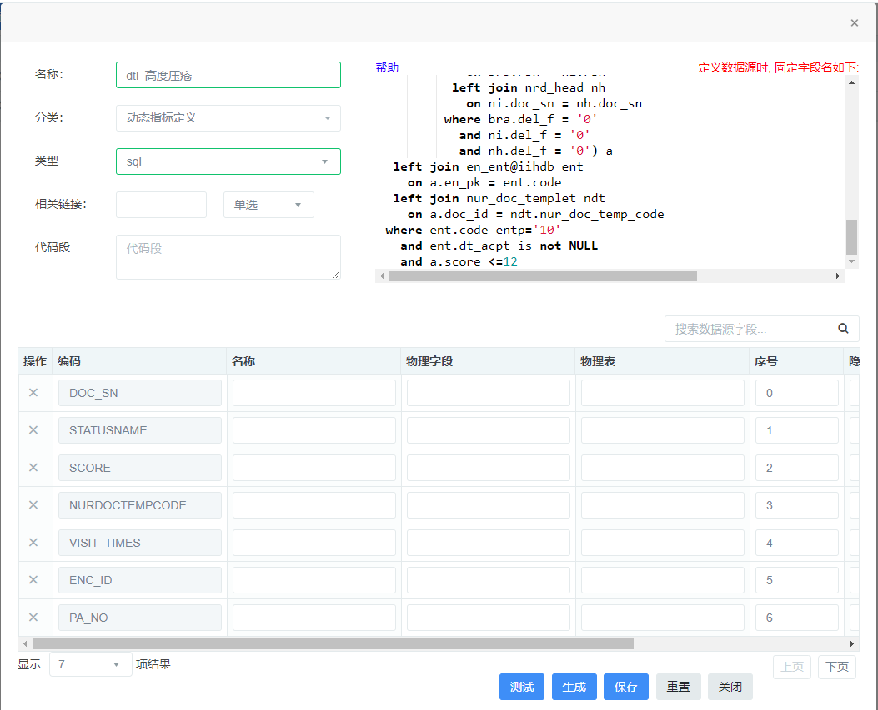

脚本：

select a.rsn as ID,

a.record_date as BIZ_TIME,

a.en_pk as ENC_ID,

a.pid as PA_ID,

a.ad_no as PA_NO,

a.visit_times as VISIT_TIMES,

a.dept as DEPT_CD,

a.ward as WARD_CD,

'压疮' as TITLE,

ndt.version_num as VERSION,

ndt.nur_doc_temp_code as NURDOCTEMPCODE,

ndt.nur_doc_temp_name as TASKNM,

a.doc_sn as DOC_SN,

a.rsn as RSN,

a.record_date as SUBTIME,

a.score as SCORE,

a.statusname as STATUSNAME,

a.nm as NM

from (select bra.rsn as rsn,

bra.record_time as record_date,

nh.en_pk as en_pk,

nh.pid as pid,

nh.ad_no as ad_no,

nh.visit_times as visit_times,

nh.dept as dept,

nh.ward as ward,

nh.doc_id as doc_id,

nh.doc_sn as doc_sn,

bra.score as score,

CASE WHEN bra.score >= 19 THEN '无风险'

when bra.score >= 15 then

'低度危险'

when bra.score >= 13 and bra.score <= 14 then

'中度危险'

when bra.score >= 10 and bra.score <= 12 then

'高度危险'

when bra.score <= 9 then

'极度危险'

else

''

end AS statusname,

bra.sign_name_hushiqianming AS nm,

--对同一患者的数据按时间倒序编号

row_number() over(partition by ni.en_pk order by bra.record_time desc) as rk

FROM nrd_data_ycfxpgbzz bra

left join nrd_item ni

on bra.rsn = ni.rsn

left join nrd_head nh

on ni.doc_sn = nh.doc_sn

where bra.del_f = '0'

and ni.del_f = '0'

and nh.del_f = '0') a

left join en_ent@iihdb ent

on a.en_pk = ent.code

left join nur_doc_templet ndt

on a.doc_id = ndt.nur_doc_temp_code

where ent.code_entp='10'

and ent.dt_acpt is not NULL

最终，在数据源管理页面中能看到两个指标成对出现：



数据源定义完成后，在护理指标定义页面护士关注卡指标上关联在高危指标：高度压疮，即完成关注卡定义。

* 1. 效果展示

页面显示时，会一次性刷新全部关注卡数据，患者存在数据时则显示关注卡围标：

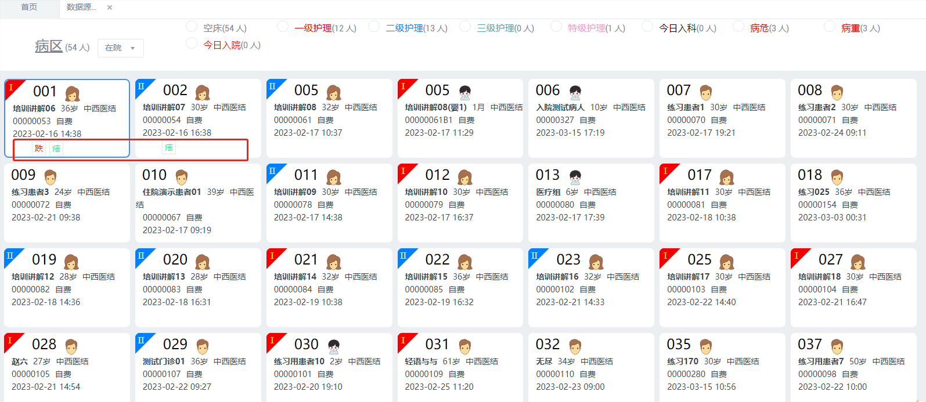

点击图标弹出指标明细，可查看明细数据和趋势图：

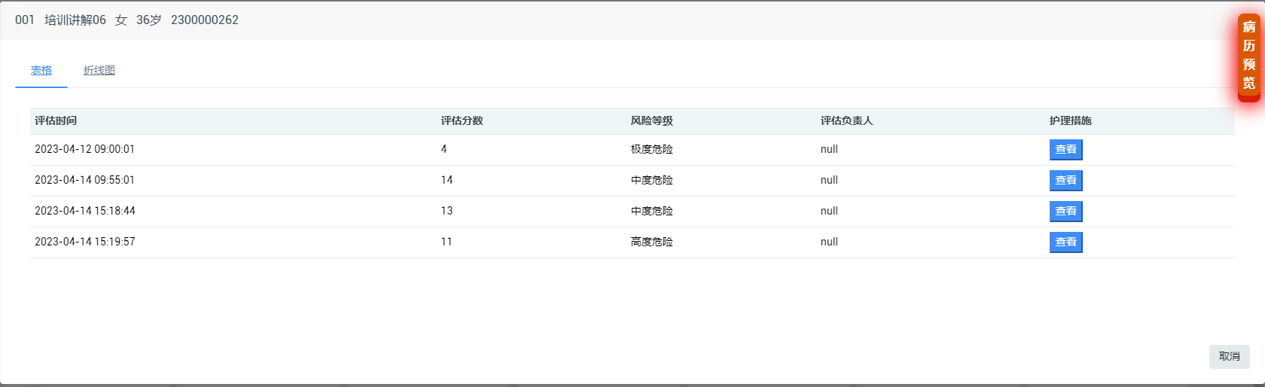

明细数据

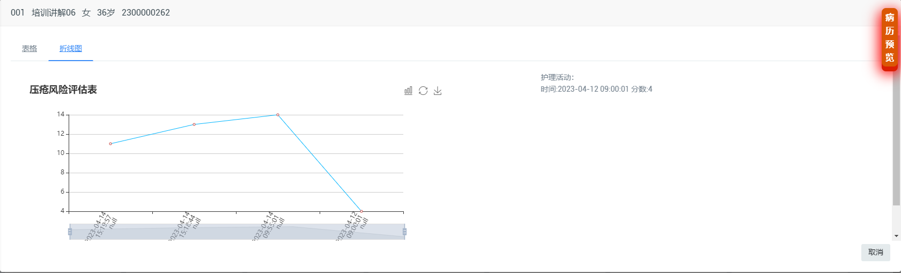

趋势图