护理归档配置手册

1. 说明

护理系统通过扩展归档接口实现和不同归档厂商进行归档，完成出院患者的文书归档。本手册对归档支持模板及相关的配置方法进行详细说明，指导项目上完成归档模式的选择和归档功能配置使用。

1. 归档模式

* 集成平台归档(M1)

护理系统将患者所有的文书生成PDF上传集成平台，归档系统从集成平台上读取PDF进行归档。

用户案例：山大一院，归档厂商：嘉禾美康

* Web服务归档(M2)

护理系统生成PDF文件调用归档系统web服务发送PDF文档完成归档。

配置参数说明：

Archive.Provider：归档模式：

固定值：com.pkuhit.cnis.doc.archive.provider.pkuhit.PkuhitArchiveServiceImpl

Archive.Provider.Pkuhit.WSDL：调用归档系统的WSDL

用户案例：烟台毓璜顶医院 归档厂商：北大医信

* 上传文档服务器归档(M3)

护理系统在患者出院时将护理文书生成PDF上传文档服务器，并在归档记录表中记录患者的归档文档名及归档时间，发布归档数据查询服务，归档系统通过调用服务查询归档文件列表，从文档服务器下载归档文件进行归档。

配置参数说明：

Archive.Provider：归档模式：

固定值：com.pkuhit.cnis.doc.archive.provider.smx.SmxArchiveServiceImpl

Archive.Provider.SMX.ip：共享文件夹所在服务器ip

Archive.Provider.SMX.account：文件夹访问用户

Archive.Provider.SMX.psw：文件夹访问密码

归档系统查询服务URL：[https://](https://localhost:8081/services/SmxArchiveService?wsdl)*[localhost:8081](https://localhost:8081/services/SmxArchiveService?wsdl)*[/services/SmxArchiveService?wsdl](https://localhost:8081/services/SmxArchiveService?wsdl) 替换ip和端口号)，归档记录表patient_archive_object.ext1数据组织格式：服务器ip/pdf存放位置/pdf文件名："smb://" + IP地址 + "/UpLoadFile/"+ptiendId + "_" + visitTims，patient_archive_object. extenal_primary_key数据格式为："CNIS_" + enc.getPatientId() + "" + enc.getInVisitTimes() + "_" + pao.getPrimaryKey()+".pdf"

application-dev.properties中修改配置，将services列为免登录列表：sso.excludedPages后面追加,/services/*

用户案例：黄河三门峡医院 归档厂商：北京CA

* 嘉禾病历归档(M4)

护理系统在患者出院时将护理文书生成PDF上传文档共享服务器，并在归档记录表中记录患者的归档文档名及归档时间，调用嘉禾归档通知服务，传患者信息、归档病历及文档存储地址信息，嘉禾病历归档系统从文档共享服务器下载归档文件进行归档。

配置参数说明：

Archive.Provider：归档模式：

固定值：com.pkuhit.cnis.doc.archive.provider.jhemr.JhEmrArchiveServiceImpl

Archive.Provider.JHEMR.ip：共享文件夹所在服务器ip 如：127.0.0.1

Archive.Provider.JHEMR.dir：共享文件夹所在服务器文档目录 如：/NurShareFile

Archive.Provider.JHEMR.account：文件夹访问用户 如：Administrator

Archive.Provider.JHEMR.psw：文件夹访问密码 如：Founder

Archive.Provider.JHEMR.wsdl:归档通知wsdl地址

Archive.Provider.JHEMR.method:归档通知调用接口

归档系统查询服务URL：http://127.0.0.1/DocumentArchive.asmx?WSDL 替换ip和端口号)，归档记录表patient_archive_object.ext1数据组织格式：服务器ip/pdf存放位置/pdf文件名："smb://" + Archive.Provider.JHEMR.ip + Archive.Provider.JHEMR.dir+ptiendId + "_" + visitTims，patient_archive_object. extenal_primary_key数据格式为："CNIS_" + enc.getPatientId() + "" + enc.getInVisitTimes() + "_" + pao.getPrimaryKey()+".pdf"

application-dev.properties中修改配置，将services列为免登录列表：sso.excludedPages后面追加,/services/*

用户案例：昌乐县人民医院 归档厂商：嘉禾美康

* 北京CA病案归档

护理系统在患者出院时将护理文书生成PDF上传文档共享服务器，并在归档记录表中记录患者的归档文档名及归档时间，调用北京CA病案归档服务，传归档文件的描述XML文件、归档文件信息，由北京CA病案归档服务进行归档。

配置参数说明：

Archive.Provider：归档模式：

固定值：com.pkuhit.cnis.doc.archive.provider.bjcamrf.BJCAMrfArchiveServiceImpl

Archive.Provider.BJCAMRF.address:北京CA病案归档服务地址

Archive.Provider.BJCAMRF.authValue:安全密钥--北京CA接口需要

Archive.Provider.BJCAMRF.hospitalName:医院编码

Archive.Provider.BJCAMRF.cnisCode:护理系统编码

归档记录表patient_archive_object. extenal_primary_key数据格式为："CNIS_" + enc.getPatientId() + "" + enc.getInVisitTimes() + "_" + pao.getPrimaryKey()+".pdf"

项目根据归档要求选择适用的模式，无适用模式时由研发进行扩展。

1. 配置说明

项目根据归档模式

* 流程归档：

通过配置业务流程，归档时调用流程进行处理，适用自动归档

系统管理/流程管理/流程功能中添加文书归档流程：

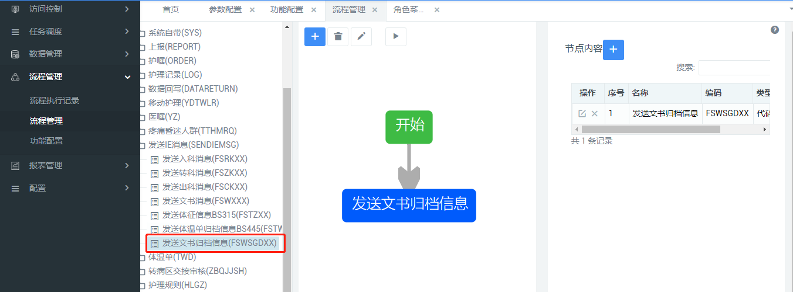

流程配置中选用代码方式，实现类选择适用的模式：

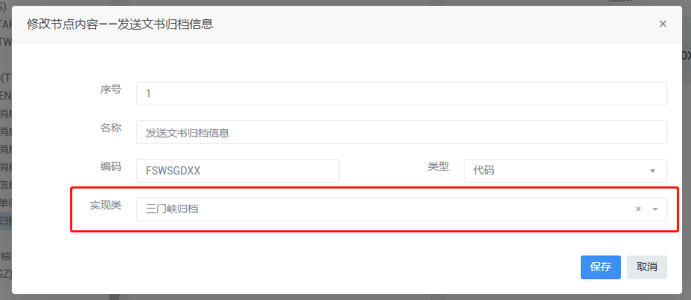

归档模式可选项：

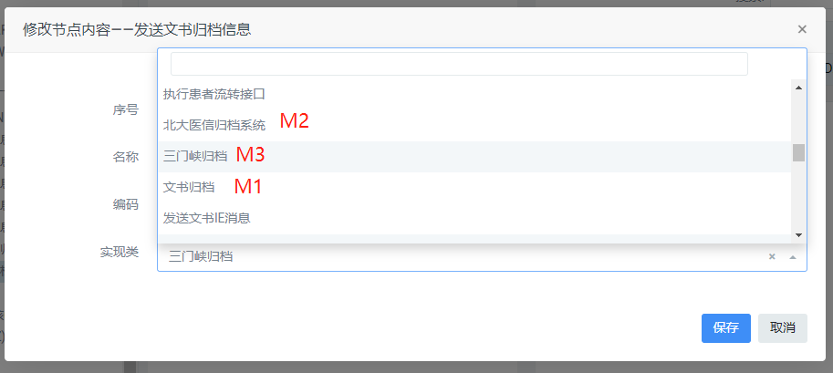

* 手工归档

手工归档通过护理系统归档管理门户进行操作。归档管理门户下添加患者归档和归档管理两个菜单，患者归档用于查询已出院的患者，按患者一次性归档，归档管理用于对出院患者按文书类型进行归档，归档查看时效用于管理不同角色可查看已归档病历的范围。

患者归档 /patient/archive/patManager

归档管理 /patient/archive/toArchive

归档查看时效 /patient/archive/toArchiveTimeLine

自动归档后也可以在手工归档相关页面中进行查看，取消归档和重新归档。

1. 数据结构

归档记录表：patient_archive_object

归档类型对照：patient_archive_type_mapping

建表语句见附页。

1. 其它配置

归档系统需要将数据转换为PDF再上传，需要部署PDF转换服务，参照《护理文书Grid++报表转PDF服务部署说明.doc》文档说明完成服务部署。

附：

归档记录表：

#sqlserver

CREATE TABLE [dbo].[patient_archive_object](

[id_pao] [varchar](32) NOT NULL,

[patient_id] [varchar](32) NOT NULL,

[admiss_times] [int] NOT NULL,

[primary_key] [varchar](256) NOT NULL,

[obj_ca] [int] NOT NULL,

[code] [varchar](256) NULL,

[name] [varchar](512) NULL,

[type_code] [varchar](256) NULL,

[type_name] [varchar](512) NULL,

[archive_flag] [int] NOT NULL,

[archive_emp_code] [varchar](256) NULL,

[archive_emp_name] [varchar](256) NULL,

[archive_time] [datetime] NULL,

[error_code] [varchar](256) NULL,

[error_msg] [varchar](4000) NULL,

[biz_time] [datetime] NULL,

[ext1] [varchar](500) NULL,

[ext2] [varchar](500) NULL,

[ext3] [varchar](500) NULL,

[report_id] [varchar](32) NULL,

[extenal_primary_key] [varchar](128) NULL,

PRIMARY KEY CLUSTERED

(

[id_pao] ASC

)WITH (PAD_INDEX = OFF, STATISTICS_NORECOMPUTE = OFF, IGNORE_DUP_KEY = OFF, ALLOW_ROW_LOCKS = ON, ALLOW_PAGE_LOCKS = ON) ON [PRIMARY]

) ON [PRIMARY]

GO

SET ANSI_PADDING OFF

GO

EXEC sys.sp_addextendedproperty @name=N'MS_Description', @value=N'对象唯一标志' , @level0type=N'SCHEMA',@level0name=N'dbo', @level1type=N'TABLE',@level1name=N'patient_archive_object', @level2type=N'COLUMN',@level2name=N'id_pao'

GO

EXEC sys.sp_addextendedproperty @name=N'MS_Description', @value=N'患者ID' , @level0type=N'SCHEMA',@level0name=N'dbo', @level1type=N'TABLE',@level1name=N'patient_archive_object', @level2type=N'COLUMN',@level2name=N'patient_id'

GO

EXEC sys.sp_addextendedproperty @name=N'MS_Description', @value=N'患者就诊次数' , @level0type=N'SCHEMA',@level0name=N'dbo', @level1type=N'TABLE',@level1name=N'patient_archive_object', @level2type=N'COLUMN',@level2name=N'admiss_times'

GO

EXEC sys.sp_addextendedproperty @name=N'MS_Description', @value=N'业务主键' , @level0type=N'SCHEMA',@level0name=N'dbo', @level1type=N'TABLE',@level1name=N'patient_archive_object', @level2type=N'COLUMN',@level2name=N'primary_key'

GO

EXEC sys.sp_addextendedproperty @name=N'MS_Description', @value=N'对象类别0: 护理文书1: 体温单' , @level0type=N'SCHEMA',@level0name=N'dbo', @level1type=N'TABLE',@level1name=N'patient_archive_object', @level2type=N'COLUMN',@level2name=N'obj_ca'

GO

EXEC sys.sp_addextendedproperty @name=N'MS_Description', @value=N'对象编码' , @level0type=N'SCHEMA',@level0name=N'dbo', @level1type=N'TABLE',@level1name=N'patient_archive_object', @level2type=N'COLUMN',@level2name=N'code'

GO

EXEC sys.sp_addextendedproperty @name=N'MS_Description', @value=N'对象名称' , @level0type=N'SCHEMA',@level0name=N'dbo', @level1type=N'TABLE',@level1name=N'patient_archive_object', @level2type=N'COLUMN',@level2name=N'name'

GO

EXEC sys.sp_addextendedproperty @name=N'MS_Description', @value=N'对象分类编码' , @level0type=N'SCHEMA',@level0name=N'dbo', @level1type=N'TABLE',@level1name=N'patient_archive_object', @level2type=N'COLUMN',@level2name=N'type_code'

GO

EXEC sys.sp_addextendedproperty @name=N'MS_Description', @value=N'对象分类名称' , @level0type=N'SCHEMA',@level0name=N'dbo', @level1type=N'TABLE',@level1name=N'patient_archive_object', @level2type=N'COLUMN',@level2name=N'type_name'

GO

EXEC sys.sp_addextendedproperty @name=N'MS_Description', @value=N'归档标志0: 未归档1: 归档中2: 归档完成3: 临时封存4: 取消封存5: 撤销归档中6: 已撤销' , @level0type=N'SCHEMA',@level0name=N'dbo', @level1type=N'TABLE',@level1name=N'patient_archive_object', @level2type=N'COLUMN',@level2name=N'archive_flag'

GO

EXEC sys.sp_addextendedproperty @name=N'MS_Description', @value=N'归档员工编码' , @level0type=N'SCHEMA',@level0name=N'dbo', @level1type=N'TABLE',@level1name=N'patient_archive_object', @level2type=N'COLUMN',@level2name=N'archive_emp_code'

GO

EXEC sys.sp_addextendedproperty @name=N'MS_Description', @value=N'归档员工姓名' , @level0type=N'SCHEMA',@level0name=N'dbo', @level1type=N'TABLE',@level1name=N'patient_archive_object', @level2type=N'COLUMN',@level2name=N'archive_emp_name'

GO

EXEC sys.sp_addextendedproperty @name=N'MS_Description', @value=N'归档时间' , @level0type=N'SCHEMA',@level0name=N'dbo', @level1type=N'TABLE',@level1name=N'patient_archive_object', @level2type=N'COLUMN',@level2name=N'archive_time'

GO

EXEC sys.sp_addextendedproperty @name=N'MS_Description', @value=N'归档异常编码' , @level0type=N'SCHEMA',@level0name=N'dbo', @level1type=N'TABLE',@level1name=N'patient_archive_object', @level2type=N'COLUMN',@level2name=N'error_code'

GO

EXEC sys.sp_addextendedproperty @name=N'MS_Description', @value=N'归档异常详情' , @level0type=N'SCHEMA',@level0name=N'dbo', @level1type=N'TABLE',@level1name=N'patient_archive_object', @level2type=N'COLUMN',@level2name=N'error_msg'

GO

EXEC sys.sp_addextendedproperty @name=N'MS_Description', @value=N'教师开课表' , @level0type=N'SCHEMA',@level0name=N'dbo', @level1type=N'TABLE',@level1name=N'patient_archive_object'

GO

ALTER TABLE [dbo].[patient_archive_object] ADD DEFAULT ((0)) FOR [obj_ca]

GO

ALTER TABLE [dbo].[patient_archive_object] ADD DEFAULT ((0)) FOR [archive_flag]

GO

#归档类型对照表

CREATE TABLE [dbo].[patient_archive_type_mapping](

[id_tm] [varchar](32) NOT NULL,

[code_internal] [varchar](255) NOT NULL,

[code_extenal] [varchar](255) NOT NULL,

PRIMARY KEY CLUSTERED

(

[id_tm] ASC

)WITH (PAD_INDEX = OFF, STATISTICS_NORECOMPUTE = OFF, IGNORE_DUP_KEY = OFF, ALLOW_ROW_LOCKS = ON, ALLOW_PAGE_LOCKS = ON) ON [PRIMARY],

UNIQUE NONCLUSTERED

(

[code_internal] ASC

)WITH (PAD_INDEX = OFF, STATISTICS_NORECOMPUTE = OFF, IGNORE_DUP_KEY = OFF, ALLOW_ROW_LOCKS = ON, ALLOW_PAGE_LOCKS = ON) ON [PRIMARY]

) ON [PRIMARY]

GO

SET ANSI_PADDING OFF

GO

EXEC sys.sp_addextendedproperty @name=N'MS_Description', @value=N'主键' , @level0type=N'SCHEMA',@level0name=N'dbo', @level1type=N'TABLE',@level1name=N'patient_archive_type_mapping', @level2type=N'COLUMN',@level2name=N'id_tm'

GO

EXEC sys.sp_addextendedproperty @name=N'MS_Description', @value=N'内部编码：twd：体温单，文书为nur_doc_templt_code' , @level0type=N'SCHEMA',@level0name=N'dbo', @level1type=N'TABLE',@level1name=N'patient_archive_type_mapping', @level2type=N'COLUMN',@level2name=N'code_internal'

GO

EXEC sys.sp_addextendedproperty @name=N'MS_Description', @value=N'外部归档系统编码' , @level0type=N'SCHEMA',@level0name=N'dbo', @level1type=N'TABLE',@level1name=N'patient_archive_type_mapping', @level2type=N'COLUMN',@level2name=N'code_extenal'

GO

EXEC sys.sp_addextendedproperty @name=N'MS_Description', @value=N'归档对象表类型对照表' , @level0type=N'SCHEMA',@level0name=N'dbo', @level1type=N'TABLE',@level1name=N'patient_archive_type_mapping'

GO

#oracle

#归档记录表

create table PATIENT_ARCHIVE_OBJECT

(

id_pao VARCHAR2(32) not null,

patient_id VARCHAR2(32) not null,

admiss_times NUMBER not null,

primary_key VARCHAR2(256) not null,

biz_time TIMESTAMP(6),

obj_ca NUMBER default 0 not null,

code VARCHAR2(256),

name VARCHAR2(512),

type_code VARCHAR2(256),

type_name VARCHAR2(512),

archive_flag NUMBER default 0 not null,

archive_emp_code VARCHAR2(256),

archive_emp_name VARCHAR2(256),

archive_time TIMESTAMP(6),

error_code VARCHAR2(256),

error_msg VARCHAR2(4000),

extenal_primary_key VARCHAR2(128),

ext1 VARCHAR2(2000),

ext2 VARCHAR2(2000),

ext3 VARCHAR2(2000),

report_id VARCHAR2(32)

)

tablespace CNISDB_IIH

pctfree 10

initrans 1

maxtrans 255;

*-- Add comments to the table*

comment on table PATIENT_ARCHIVE_OBJECT

is '患者归档对象表';

*-- Add comments to the columns*

comment on column PATIENT_ARCHIVE_OBJECT.id_pao

is '对象唯一标志';

comment on column PATIENT_ARCHIVE_OBJECT.extenal_primary_key

is '第三方归档系统返回的业务主键';

comment on column PATIENT_ARCHIVE_OBJECT.ext1

is '扩展字段1';

comment on column PATIENT_ARCHIVE_OBJECT.ext2

is '扩展字段2';

comment on column PATIENT_ARCHIVE_OBJECT.ext3

is '扩展字段3';

*-- Create/Recreate indexes*

create unique index IDX_PAO_PRIMARY_KEY on PATIENT_ARCHIVE_OBJECT (PRIMARY_KEY)

tablespace CNISDB_IIH

pctfree 10

initrans 2

maxtrans 255;

*-- Create/Recreate primary, unique and foreign key constraints*

alter table PATIENT_ARCHIVE_OBJECT

add primary key (ID_PAO)

using index

tablespace CNISDB_IIH

pctfree 10

initrans 2

maxtrans 255;

#归档类型对照表

create table PATIENT_ARCHIVE_TYPE_MAPPING

(

id_tm VARCHAR2(32) not null,

code_internal VARCHAR2(255) not null,

code_extenal VARCHAR2(255) not null

)

tablespace CNISDB_IIH

pctfree 10

initrans 1

maxtrans 255;

*-- Add comments to the table*

comment on table PATIENT_ARCHIVE_TYPE_MAPPING

is '归档对象表类型对照表';

*-- Add comments to the columns*

comment on column PATIENT_ARCHIVE_TYPE_MAPPING.code_internal

is '内部编码：twd：体温单，文书为nur_doc_templt_code';

comment on column PATIENT_ARCHIVE_TYPE_MAPPING.code_extenal

is '外部归档系统编码';

*-- Create/Recreate primary, unique and foreign key constraints*

alter table PATIENT_ARCHIVE_TYPE_MAPPING

add primary key (ID_TM)

using index

tablespace CNISDB_IIH

pctfree 10

initrans 2

maxtrans 255;

alter table PATIENT_ARCHIVE_TYPE_MAPPING

add unique (CODE_INTERNAL)

using index

tablespace CNISDB_IIH

pctfree 10

initrans 2

maxtrans 255;