护理文书CNIS体温单绘制

总出入量数据个性化获取操作说明

1. 引言

针对实现各别医院体温单绘制-总出入量获取数据的个性化规则需求，明确配置和实现说明。

1. 步骤说明

2.1 创建存储过程获取出入量数据

|  |
| --- |
| ----------示例存储过程--------  /****** Object: StoredProcedure [dbo].[qry_tc_intakeAndOutput_data] Script Date: 2021/7/09 16:00:28 ******/  SET ANSI_NULLS ON  GO  SET QUOTED_IDENTIFIER ON  GO  CREATE PROCEDURE [dbo].[qry_tc_intakeAndOutput_data]  @encId varchar(10),  @startDate varchar(20),  @endDate varchar(20),  @idVs varchar(50),  @idVsItem varchar(50)  AS  set nocount on  BEGIN  select col.id_col,  col.measure_time,  col.id_enc,  convert(datetime, (convert(varchar(10), col.measure_time,23)+' 10:00:00')) as draw_datetime,  coli.id_col_item,  coli.id_vs,  coli.id_vs_item,  coli.name ,  coli.value,  vs.id_show_rule,  vs.sd_show_rule,  vsi.id_data_origin,  vsi.sd_data_origin,  vsi.fg_default  into #temp_table  from tc_col_item coli  left join tc_col col on col.id_col = coli.id_col  left join tc_vs_item vsi on vsi.id_vs_item = coli.id_vs_item  left join tc_vs vs on vs.id_vs = coli.id_vs  where coli.del_f='0' and coli.id_col in(  select id_col from tc_col where del_f='0' and id_enc=@encId  and measure_time <=@endDate and measure_time >=@startDate)  and coli.id_vs=@idVs  select  id_enc as "encId",  CONVERT(VARCHAR(10),draw_datetime,23) as "measureDate",  REPLACE(left(CONVERT(VARCHAR(10),draw_datetime, 108),5), ':', '') as "hhmm",  CONVERT(VARCHAR(16), draw_datetime, 120) as "measureTime",  CONVERT(VARCHAR(19), draw_datetime, 120) as "measureDateTime",  id_vs as "idVs",  id_vs_item as "idVsItem",  name as "name",  name as "nameVs",  sum(convert(numeric(10, 2), value)) as "value",  id_show_rule as "idShowRule",  sd_show_rule as "sdShowRule",  id_data_origin as "idDataOrigin",  sd_data_origin as "sdDataOrigin",  fg_default as "fgDefault"  from #temp_table  where isnumeric(value)=1  group by id_enc,  draw_datetime,  id_vs,  id_vs_item,  name ,  id_show_rule,  sd_show_rule,  id_data_origin,  sd_data_origin,  fg_default  drop table #temp_table  END  GO |

**以上为示例存储过程：参数、返回结果集字段为固定格式，数据获取个性化需求由现场自定义实现。**

**以上为示例存储过程：参数、返回结果集字段为固定格式，数据获取个性化需求由现场自定义实现。**

**以上为示例存储过程：参数、返回结果集字段为固定格式，数据获取个性化需求由现场自定义实现。**

2.2 创建数据源调用存储过程

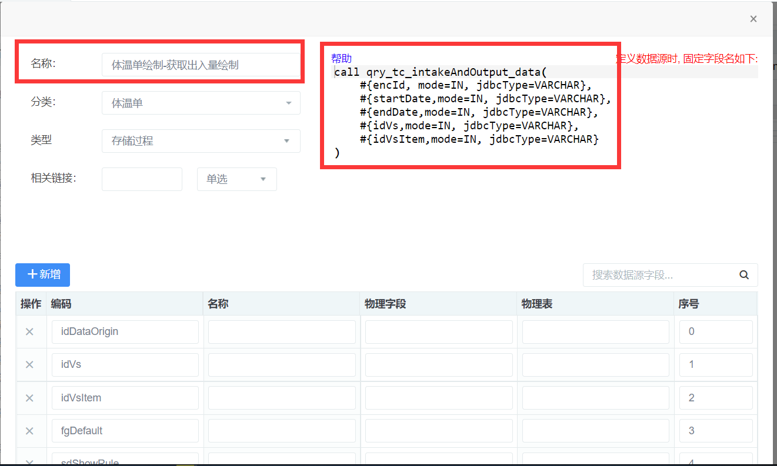

|  |
| --- |
| call qry_tc_intakeAndOutput_data(  #{encId, mode=IN, jdbcType=VARCHAR},  #{startDate,mode=IN, jdbcType=VARCHAR},  #{endDate,mode=IN, jdbcType=VARCHAR},  #{idVs,mode=IN, jdbcType=VARCHAR},  #{idVsItem,mode=IN, jdbcType=VARCHAR}  ) |

2.3 关联数据源与体征项

