1. 在plsql工具中创建存储过程，将SQL复制到SQL窗口，执行

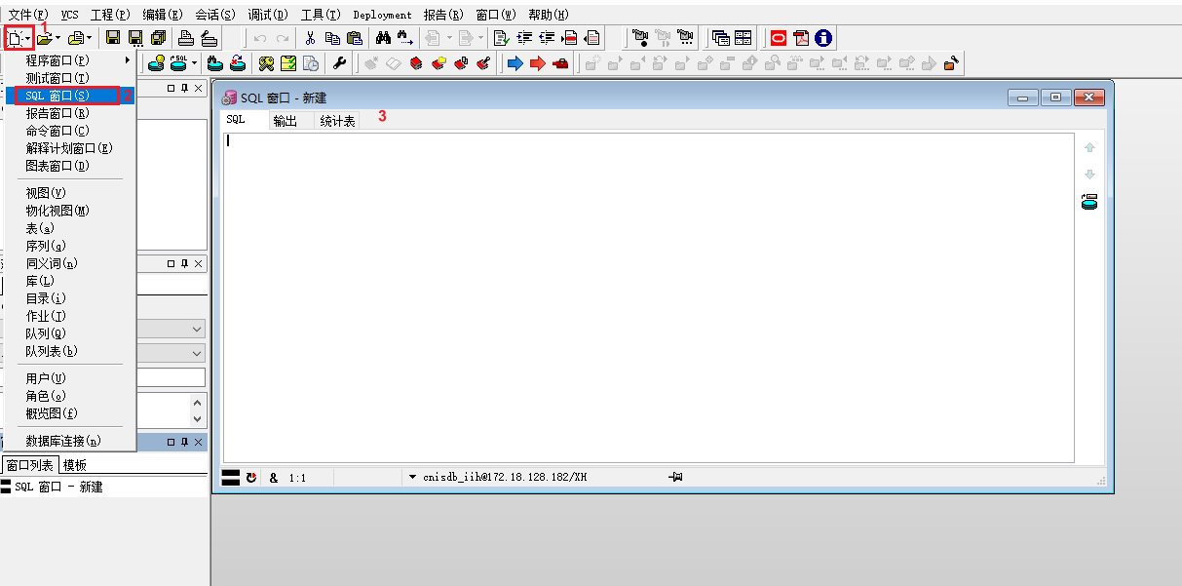

|  |
| --- |
| CREATE OR REPLACE PROCEDURE qry_tc_huxi_data_tonghua *-- 通化呼吸体温绘制-数据源*  (  encId IN VARCHAR2,  startDate IN VARCHAR2,  endDate IN VARCHAR2,  exeRe OUT sys_refcursor )  AS  v_tiwen_idVs VARCHAR2(32) := '9cf7a466d3304c55a98136987765db3c'; *--体温id_vs*  v_huxi_idVs VARCHAR2(32) := '18329c240b104be79ae8e11e49384220'; *--呼吸id_vs*  BEGIN  OPEN exeRe FOR  with v_col as(  select * from (  select col.id_col,  to_char(col.measure_time, 'hh24') as hh,  to_char(col.measure_time, 'yyyy-MM-dd') as measure_date,  to_char(col.measure_time, 'yyyy-MM-dd hh24:mi:ss') as mt,  (case when to_number(REPLACE(to_char(measure_time, 'hh24:mi'), ':', '')) <= 400 then 'A'  when to_number(REPLACE(to_char(measure_time, 'hh24:mi'), ':', '')) <= 800 then 'B'  when to_number(REPLACE(to_char(measure_time, 'hh24:mi'), ':', '')) <= 1200 then 'C'  when to_number(REPLACE(to_char(measure_time, 'hh24:mi'), ':', '')) <= 1600 then 'D'  when to_number(REPLACE(to_char(measure_time, 'hh24:mi'), ':', '')) <= 2000 then 'E'  else 'G' end) as gridNum,  col.measure_time from  (select col.id_col from tc_col col  left join tc_col_item item on col.id_col = item.id_col  where col.del_f = '0'  and item.del_f = '0'  and (id_vs = v_huxi_idVs or id_vs=v_tiwen_idVs)  and length(trim(value)) > 0  and col.id_enc = encId  and measure_time between  to_date(startDate, 'yyyy-MM-dd hh24:mi:ss') and  to_date(endDate, 'yyyy-MM-dd hh24:mi:ss')  group by col.id_col,id_vs having count(1)>1) colemp  inner join tc_col col on colemp.id_col=col.id_col and col.id_enc=encId  inner join tc_col_item item on colemp.id_col=item.id_col and id_vs= v_huxi_idVs  ) abc order by abc.mt,abc.gridNum  )  select coli.id_col as "idCol",  coli.id_col_item as "idColItem",  to_char(measure_time,'yyyy-MM-dd hh24:mi:ss') as "measureTime",  to_char(measure_time,'yyyy-MM-dd') as "measureDate",  REPLACE(to_char(measure_time, 'hh24:mi'), ':', '') as "hhmm",  vitm.name as "name",  tv.name as "nameVs",  vitm.fg_default as "fgDefault",  tv.id_vs as "idVs",  coli.value as "value",  'TCVS04.50' as "idShowRule",  '数据源' as "sdShowRule",  xu.nm as "lastUserName"  from (  select id_col,measure_time  from (select *  from (select a.*,  row_number() over(partition by measure_date, gridNum order by measure_time) rn  from (select *  from v_col  ) a) bb  where bb.rn = 1) cc  ) cc  left join tc_col_item coli on cc.id_col = coli.id_col and coli.del_f='0' and coli.id_vs=v_huxi_idVs  left join tc_vs_item vitm on vitm.id_vs_item = coli.id_vs_item  left join tc_vs tv on tv.id_vs = coli.id_vs  left join xap_user xu on coli.last_upd_user_id = xu.user_id and xu.del_f='0'  order by measure_time,vitm.code;  end; |



1. 在系统管理中创建数据源使用第一步的存储过程

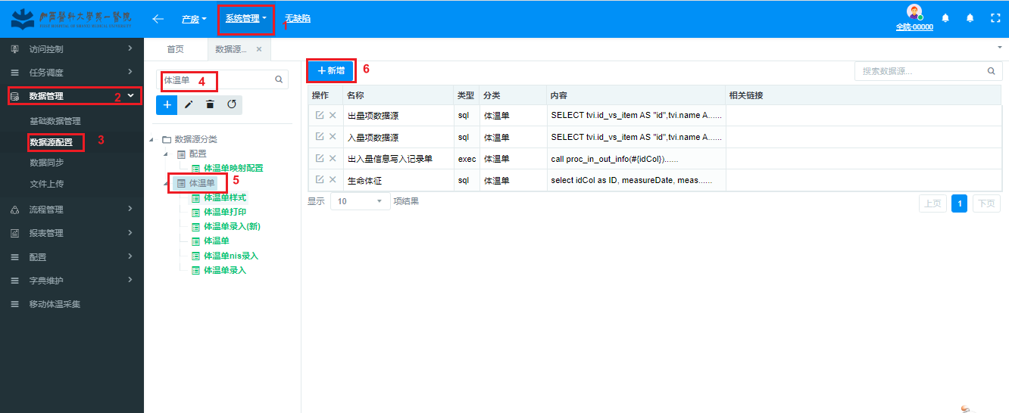

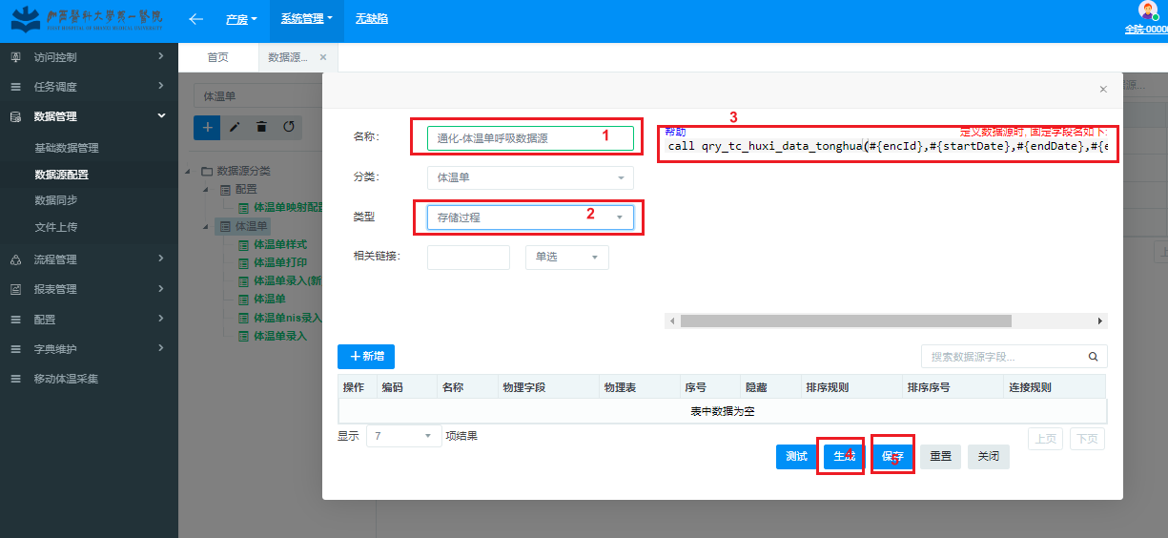

call qry_tc_huxi_data_tonghua(#{encId},#{startDate},#{endDate},#{exeRe,mode=OUT})

1. 体征项目中呼吸一项使用第二步创建的数据源

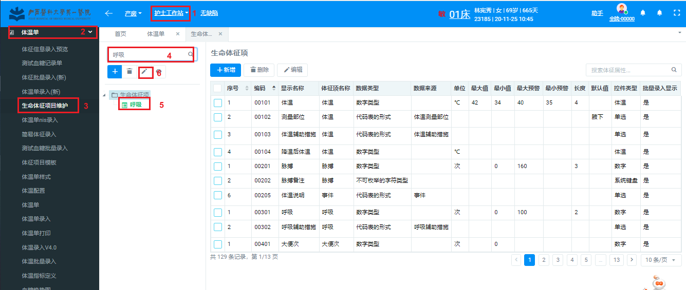

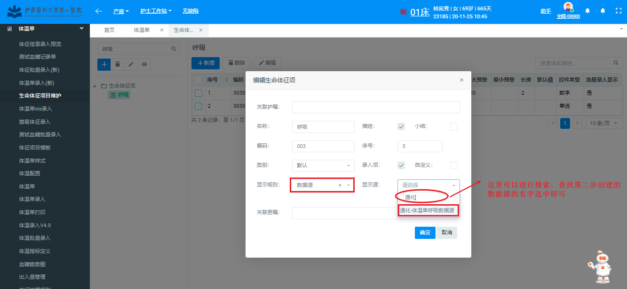

最后点击“确定”即可

4、最后看一下，体温单 绘制效果 是否符合医院要求即可