# 查询系统科室对应的字段

|  |
| --- |
| select * from ward_dept; |

通过查询该表判断wardSn还是deptSn是科室对应字段，一般为wardSn

1. **设置流程**

## 2.0、前提准备：设置业务引用模板

### 2.0.1、设置数据源

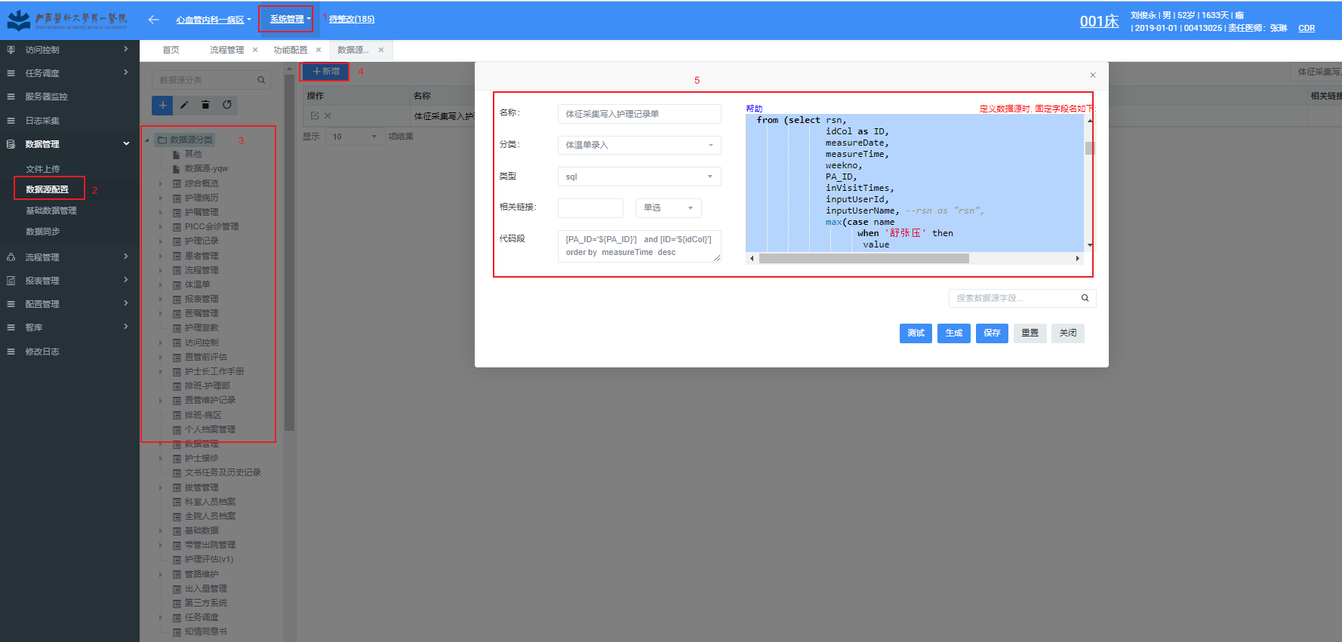

**代码段：**

**[PA_ID='${PA_ID}'] and [ID='${idCol}']**

**order by measureTime desc**

体征采集信息参考SQL

|  |
| --- |
| 1. 首先查看体征对应的ID_VS   select * from tc_vs where name = '呼吸' or name = '血氧饱和度' or name = '血压' or name = '脉搏' or name = '体温' or name = '心率'  一般对应关系为  40d5576120f8487b941f3c33d6f0b5fa 血氧饱和度  18329c240b104be79ae8e11e49384220 呼吸  2a615e5e3ed34daa996075d43dc431bd 血压  6968c1ed1f194e5e8ef769e51295a3a8 脉搏  9cf7a466d3304c55a98136987765db3c 体温  b2647f7b32ac4b3e86dbc6d13dce4436 心率   1. 其次修改SQL中的ID_VS   select rsn,  ID,  measureDate,  measureTime,  weekno,  PA_ID,  inVisitTimes,  inputUserId,  inputUserName, *--rsn as "rsn",*  szy,  ssy,  hx,  mb,  xl,  tw,  xy  from (select rsn,  idCol as ID,  measureDate,  measureTime,  weekno,  PA_ID,  inVisitTimes,  inputUserId,  inputUserName, *--rsn as "rsn",*  max(case name  when '舒张压' then  value  else  null  end) as szy,  max(case name  when '收缩压' then  value  else  null  end) as ssy,  max(case name  when '呼吸' then  value  else  null  end) as hx,  max(case name  when '脉搏' then  value  else  null  end) as mb,  max(case name  when '心率' then  value  else  null  end) as xl,  MAX(CASE name  WHEN '体温' then  value  else  null  end) as tw,  max(case name  when '血氧饱和度' then  value  else  null  end) as xy  from (select distinct nrdEleItem.rsn,  to_char(measure_time, 'yyyy-MM-dd') measureDate,  to_char(measure_time, 'yyyy-MM-dd hh24:mi:ss') as measureTime,    tc.id_col as idCol,  tc.weekno as weekno,  tc.id_patient as PA_ID,  tc.in_visit_times as inVisitTimes,  tc.last_upd_user_id as inputUserId,  emp.nm as inputUserName,    tci.name as name,  tci.value as value  from tc_col tc  left join org_emp emp  on tc.last_upd_user_id = emp.emp_id  left join tc_col_item tci  on tc.id_col = tci.id_col  left join tc_vs tcvs  on tci.id_vs = tcvs.id_vs  left join tc_vs_item tvi  on tci.id_vs_item = tvi.id_vs_item    left join nrd_data_to_tc_item nrdEleItem  on tci.id_col_item = nrdEleItem.id_col_item    where tc.del_f = '0'  and tvi.del_f = '0'  and tci.del_f = '0'  and tcvs.del_f = '0'  and (tci.id_vs = '18329c240b104be79ae8e11e49384220' or  tci.id_vs = '2a615e5e3ed34daa996075d43dc431bd' or  tci.id_vs = '6968c1ed1f194e5e8ef769e51295a3a8' OR  tci.id_vs = '9cf7a466d3304c55a98136987765db3c' or  tci.id_vs = '40d5576120f8487b941f3c33d6f0b5fa' or  tci.id_vs = 'b2647f7b32ac4b3e86dbc6d13dce4436')  and tci.value is not null) col    group by rsn,  idCol,  measureDate,  measureTime,  weekno,  PA_ID,  inVisitTimes,  inputUserId,  inputUserName) abc  where (length(szy) != 0 or length(ssy) != 0 or length(hx) != 0 or  length(mb) != 0 or length(xl) != 0 or length(tw) != 0 or  length(xy) != 0) |

### 2.0.2、设置业务引用模板

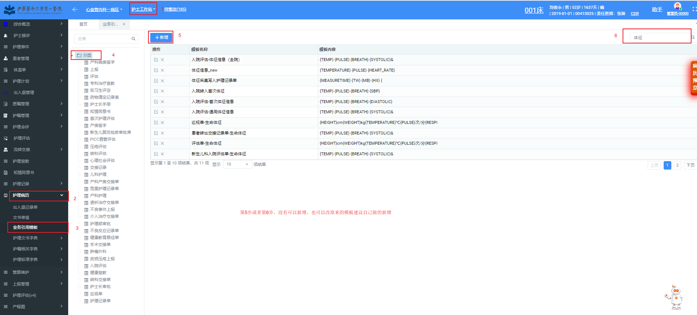

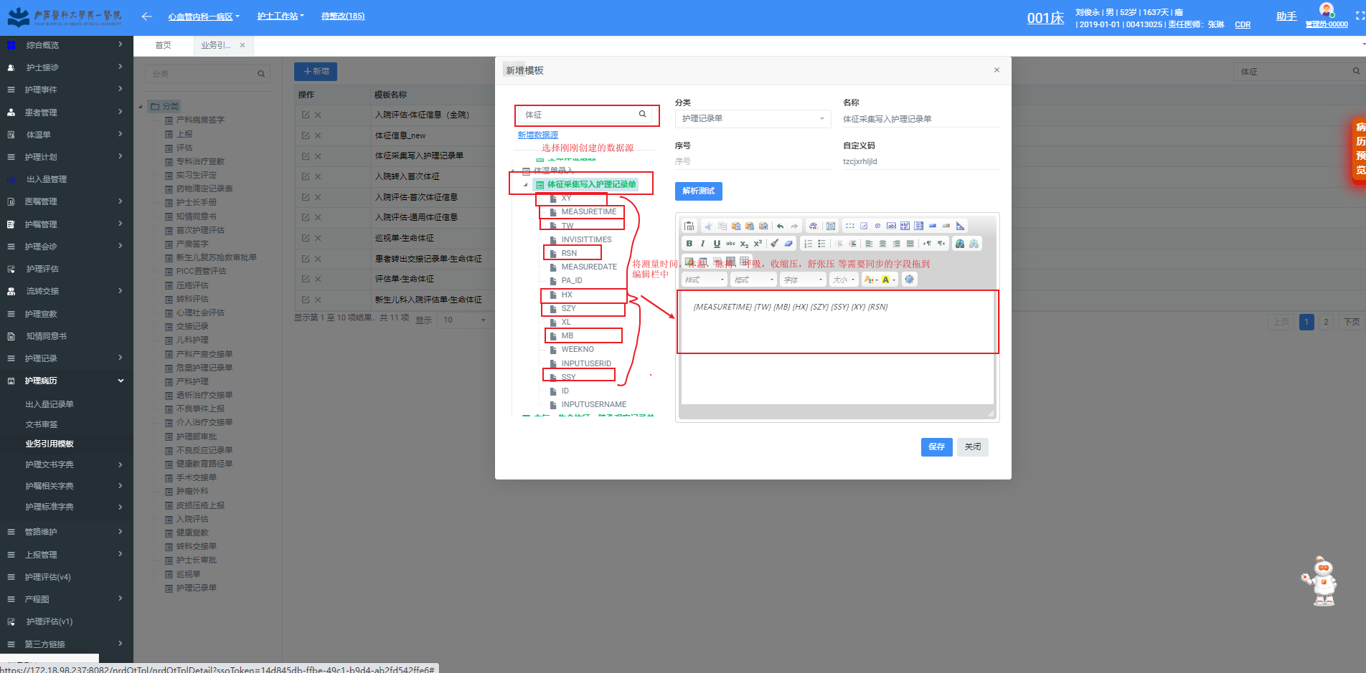

RSN必须值

设置字段对应，数据源中的字段 要和 “文书模板制作” 菜单中对应文书的字段一一对应，也就是以下两张图片的字段示例：

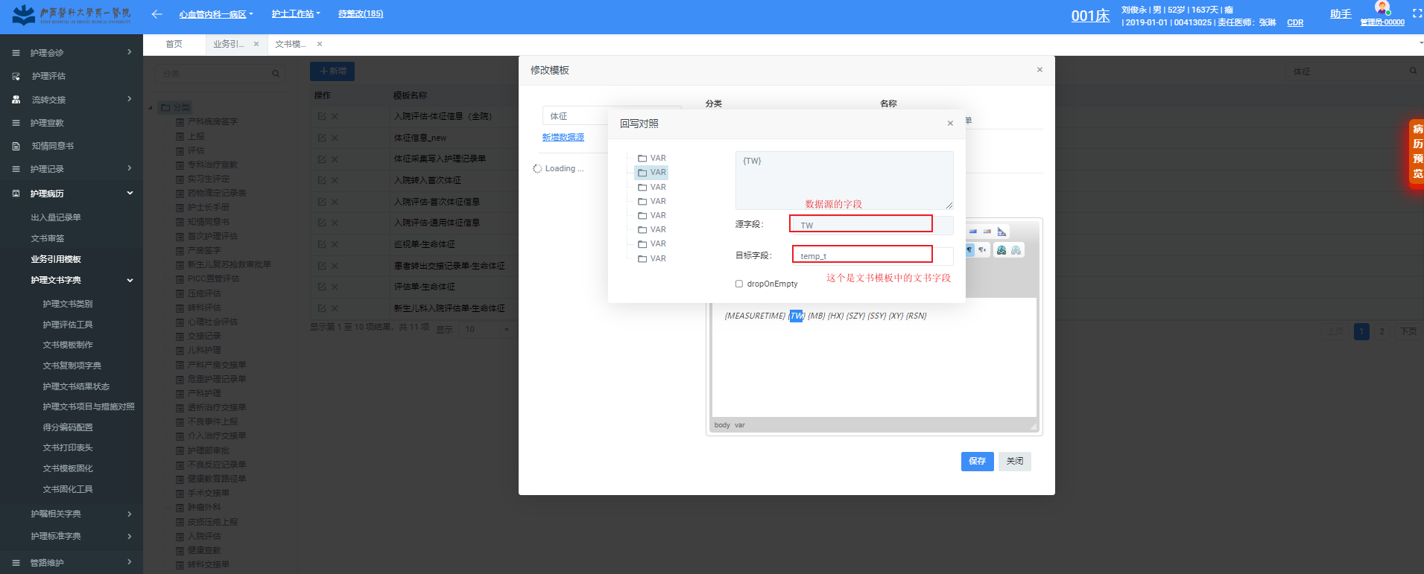

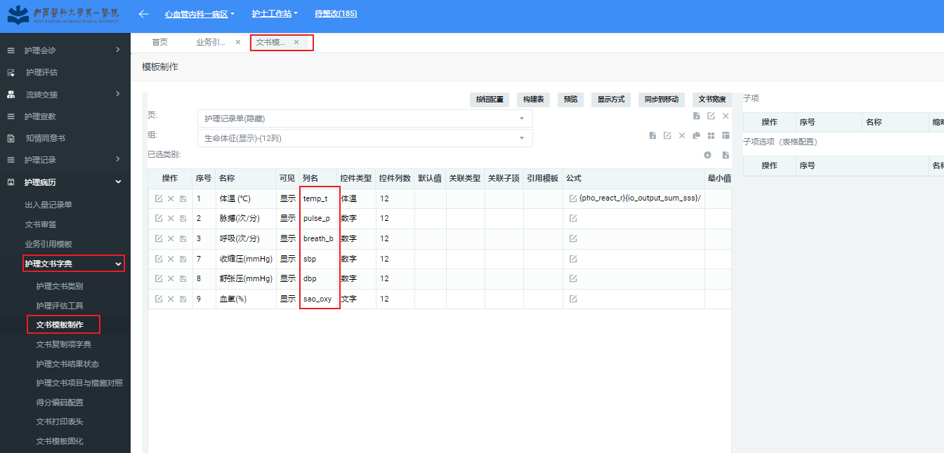

RSN对应RSN

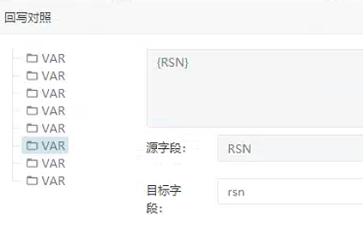

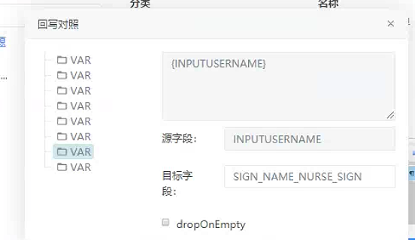

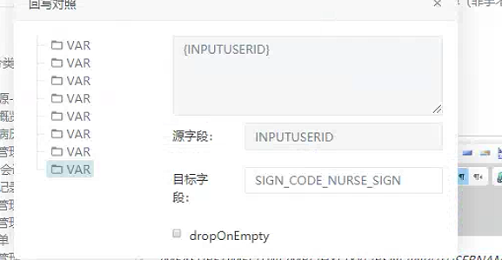

## 2.1、新建流程

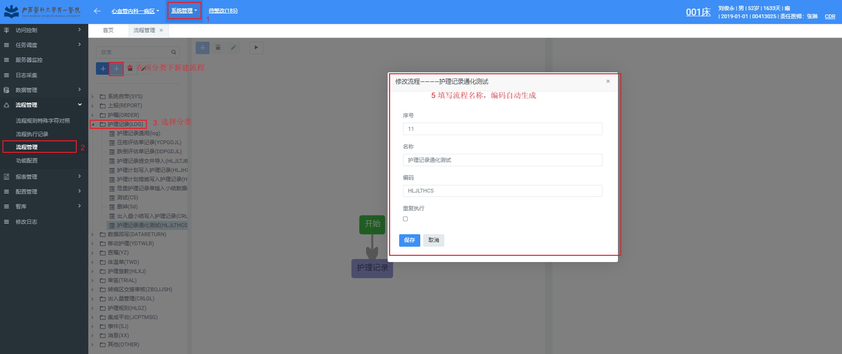

## 2.2、添加节点

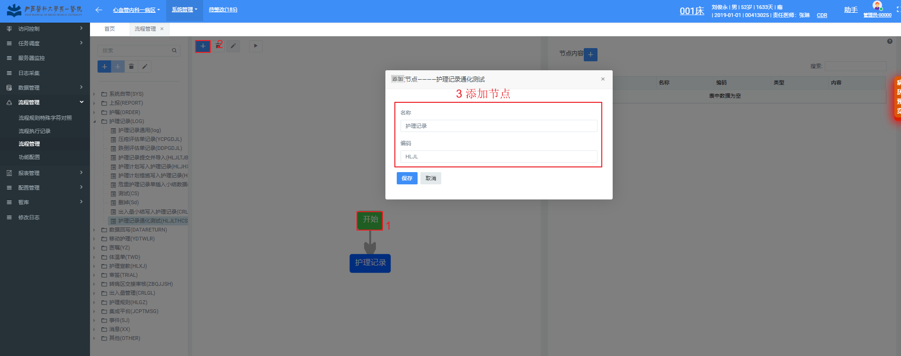

## 2.3、设置节点内容

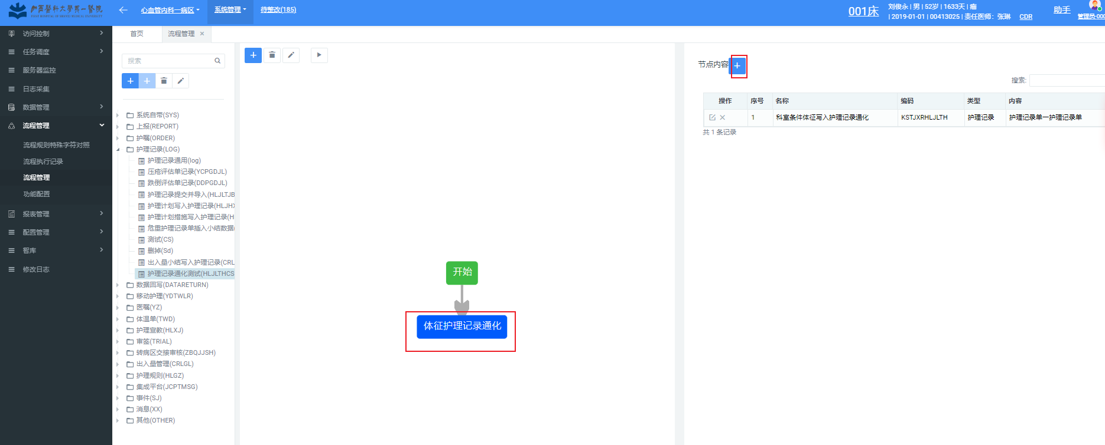

选择准备步骤中设置的“业务引用模板”

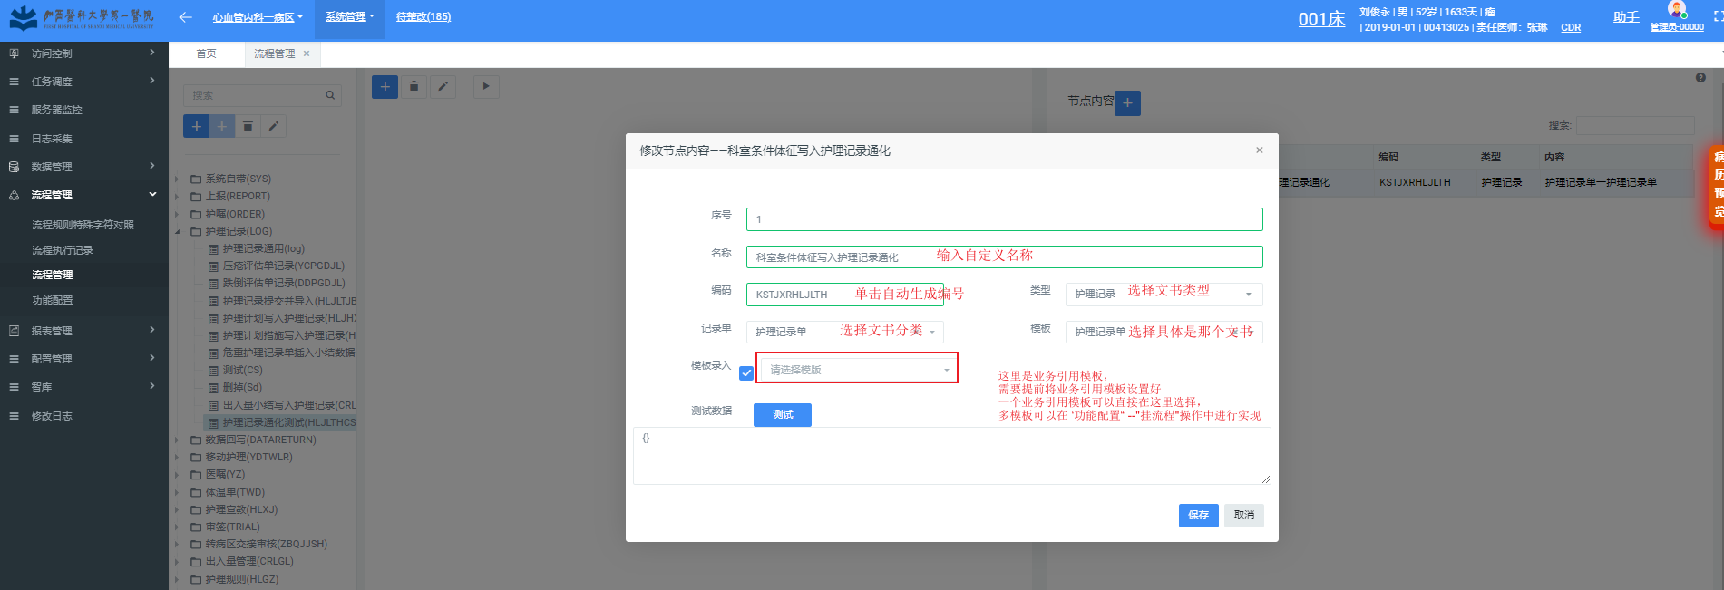

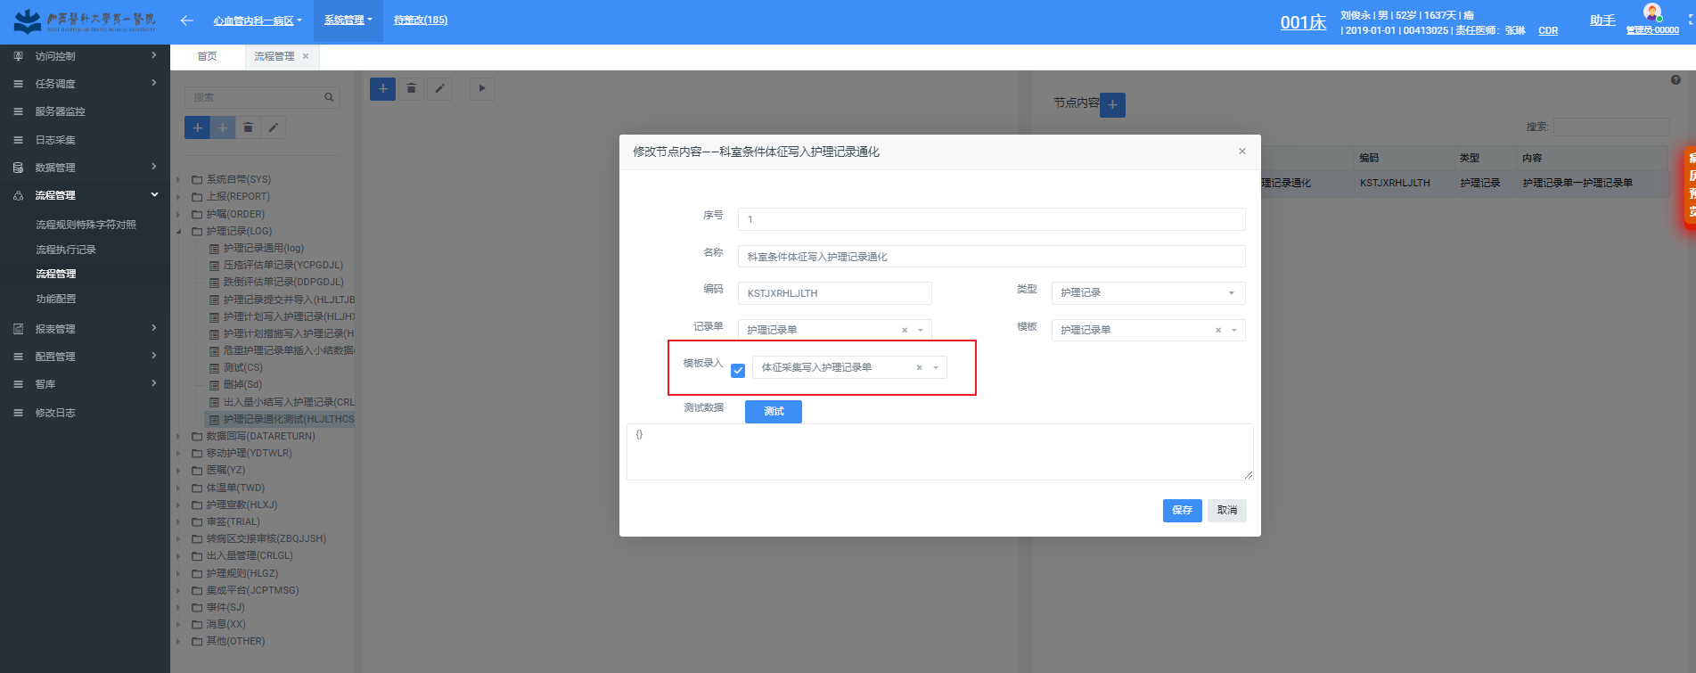

设置条件举例当科室是心血管内科时才进行同步，可用条件字段可以通过查询event_log表进行确实，即查询测试数据SQL

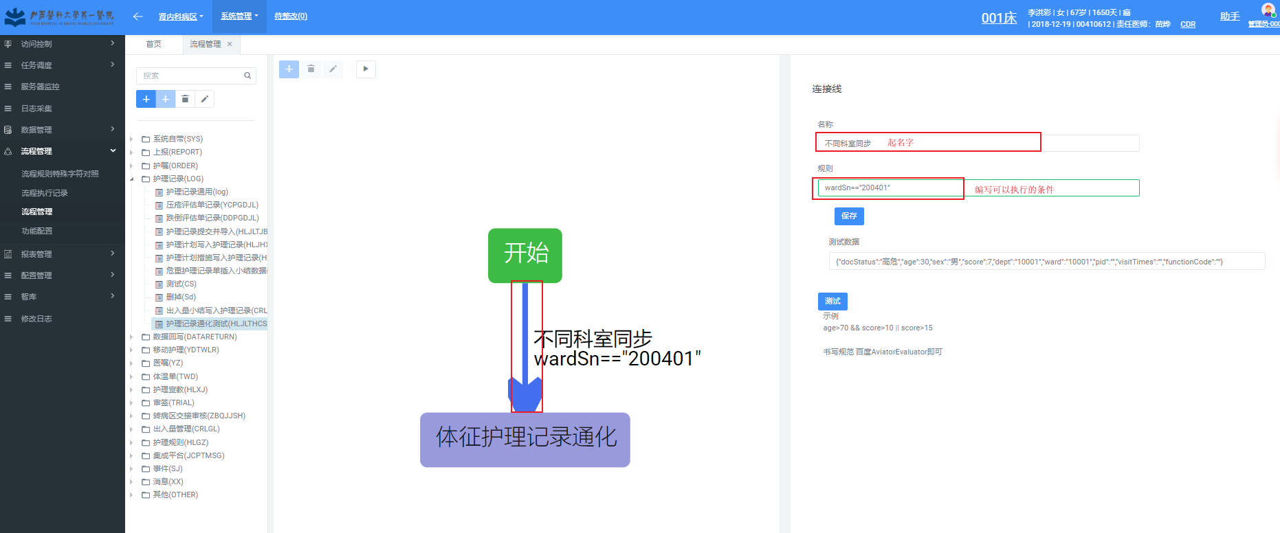

附：查询科室SQL

|  |
| --- |
| select * from ward_dept; |

测试数据可以从event_log中查看，可以判断可以用的条件字段是什么，SID是功能配置中的SID。

|  |
| --- |
| select SID,to_char(content) as content from event_log where sid = 'TWLR'; |

1. **在“功能配置”模块：体温录入(TWLR)、体温编辑(TWLR_UPD) 、体温删除(TWLR_DEL)节点挂写入护理记录的流程。**

